Datacamp Courses to Complete

Python

1. Review concepts intro & intermediate Python (Pg 4 – 6)
2. Supervised Learning with scikit-learn (Pg 13 – 32)
3. Machine Learning with Tree-Based Models in Python (pg 36-71)
4. Extreme Gradient Boosting with XGBoost (pg 71 – 86 )
5. Hyper-parameter tuning in Python (Informed Search) (pg 86 – 97)
6. Linear Classifiers in Python (SVM)
7. Unsupervised Learning in Python
8. Introduction to Deep Learning in Python
9. Introduction to TensorFlow in Python
10. Introduction to deep learning with Keras
11. Advanced deep learning with Keras
12. Introduction to Network Analysis in Python
13. Preprocessing for Machine Learning in Python
14. Feature Engineering for Machine Learning in Python
15. Winning Kaggle competitions in Python
16. Clustering Methods with SciPy
17. Dimensionality Reduction in Python
18. Machine Learning for Time Series Data in Python
19. Introduction to NLP in Python
20. Feature Engineering for NLP in Python
21. Introduction to PySpark
22. Machine Learning with PySpark
23. Pandas Foundations
24. Manipulating dataframes with Pandas
25. Introduction to Financial Concepts in Python
26. Introduction to Data Visualization with Matplotlib
27. Introduction to data visualization with Seaborn
28. Intermediate data visualization with Seaborn
29. Working with Geospatial Data in Python
30. Visualizing Geospatial Data in Python

R

1. Introduction to R (Pg 2 – 3)
2. Intermediate R (Pg 7 - 12)
3. Introduction to writing functions in R (33-35)
4. Experimental Design in R
5. Data analysis in R, the data table way
6. Data manipulation with data.table in R
7. Data visualization with ggplot2 in R (Part 1 and 2)
8. A/B Testing in R
9. Linear Algebra for Data Science in R
10. Introduction to R for Finance
11. Intermediate R for Finance
12. Manipulating Time Series Data with xts and zoo in R
13. Time Series Analysis in R
14. Forecasting in R

Other Courses to Look at

1. Spark
2. Hadoop
3. SQL (Lots of Courses)
4. Introduction to Tableau
5. Customer Analytics and A/B Testing in Python
6. Analyzing Social Media Data in Python
7. Building Dashboards with shiny dashboard
8. Data Science for Business

Introduction to R

**Data Types**

1. **Numerics** are decimal values like floats in Python
2. **Intergers** are whole numbers
3. **Logicals** are like Booleans in python
4. **Characters** are like strings in Python

Use the c( ) function to create vectors in R.

Use the names( ) function to give names to elements within a vector.

1. Assign names to a variable vector so you can re-use it, such as in days of the week

Use the sum( ) function to get the sum of a vector in R.

To get the first element of a vector in r, use [1], unlike [0] in Python.

You can use a vector in square brackets to get specific elements from R. Such as [c(1, 5)] will get the first and fifth element.

1. To do a range of elements, it’s [2:4], which will pull the 2nd to the 4th element.
2. You can also pull elements using their names such as [“Friday”] or [c(“Monday”, “Tuesday”)]

Use mean( ) to calculate the average of a vector.

Boolean operators in R: <, >, <=, >=, ==, !=

To filter certain values from a vector use the vector within the filter in brackets:

1. poker_vector[poker_vector > 0]

To construct a matrix, use the matrix function:

1. matrix1 = matrix(1:9, byrow = TRUE, nrow = 3)
2. byrow indicates whether we want the numbers by rows, or by columns
3. nrow indicates the number of rows that the matrix should have
4. Use colnames( ) and rownames( ) to name the rows and columns of a matrix
5. To calculate the sums of each row use the rowSums( ) function and the sums of each row are outputted as a new vector
6. You can then add that vector to a matrix using the **cbind( )** function
7. To add two matricies together use the **rbind( )** function

Selecting elements from matricies:

1. Follows this logic: matrix[row , column]
2. Select all elements from first column matrix[, 1]
3. Select all elements from the first row matrix[1,]
4. Select elements from rows 1,2,3 and columns 2,3,4 matrix[1:3, 2:4]

We can perform arithmetic calculations on matricies. We can also multiply and divide matricies by each other.

**For more than 2 dimensions, use arrays:**

1. To create a 4 dimensional array use: array(1:81, c(3,3,3,3))

**Factor** is a data type used to store categorical variables.

1. Use factor( ) function to convert a vector into a factor data type
2. For **ordinal categorical variables,** set order = TRUE, and levels = c(low, medium, high) for example, when the order of information matters
3. Use the levels( ) function on a factor data type to change the ordering
4. You can’t compare different factors with the traditional comparison operators

**To get a better understanding of a variable, use the summary( ) function.**

**Dataframe** is a table that can hold many different types of variables in R:

1. Use the head( ) function to get a glimpse of the first few rows, or tail( ) for the last few rows
2. To see the structure of a data frame, use str( ) function
3. Use data.frame( ) function to pass vectors into a dataframe, but they must be the same length.
4. Just like vectors and matricies, we can pull data from a data frame using [ ], we just do data_frame[ row, colum ]
5. You can also use a dollar sign to select an entire column: data_frame$column1
6. We can put in another vector within the square brackets to filter from a dataframe, such as only those that have a true value, based on the rows:

data_frame[ column1 > 0, ]

1. You can also use the subset( ) function to subset a dataframe based on a condition.
2. You can use the order( ) function to get the ordered values from a vector, then use vector[order(vector)] to put the values in order.
3. To order a dataframe use: data_frame[order(dataframe$column1), ]

**Lists** in R allow you to gather a variety of objects under a single name:

1. Use list( ) function to create a list, which can hold all types of objects like vectors, matricies, and data frames
2. Use the names( ) function to name elements in a list
3. Can also use list(name1 = element1, name2 = element2, etc.)
4. To select elements from lists use double brackets list[[1]] selects the first element, to select an element within an element use list[[1]][2], with single brackets for the next part.

Review of Python Concepts (Intro & Intermediate)

Numpy

**Numpy:** Used to quickly calculate mathematical operations over a large number of values.

1. You can’t perform calculations on python lists.
2. Use pip3 install numpy to install numpy
3. Start with **import numpy as np** to start numpy

To calculate BMI:

1. Create numpy array for height: **np_height = np.array(height)**
2. Create numpy array for weight: **np_weight = np.array(weight)**
3. BMI = np_weight / np_height j** 2

Difference between lists and np arrays:

1. lists addition: list1 + list 2, will create a larger list
2. numpy array addition: np1 + np2 will add values within each list

**Numpy subsetting:** you can perform subsetting within numpy arrays such as:

1. BMI[ BMI > 23]

To create a numpy array from a list, use np.array( ) function.

Numpy arrays can’t contain elements of different types, and the arithmetic operators such as +, -, *, and / are different for numpy arrays than regular lists.

It’s possible to create numpy arrays in multiple dimensions.

To get the **shape of a numpy array**  use the function np.shape, also a Numpy array can only hold one type.

You can index 2D Numpy arrays using np_array[ row, column]

To select only the first row, use np_array[1 , :]

**Numpy Functions:**

1. np.mean( ) to calculate mean of numpy array.
2. np.median( ) to calculate median.
3. np.corrcoef to calculate correlation coefficient
4. np.std to calculate standard deviation
5. np.sum to calculate sum
6. np.sort to sort
7. **Because Numpy forces a single data type, things go much faster**
8. np.random.normal(mean, std, number of sims) to run normal distribution simulations
9. np.column stack to paste two columns together such as np.column_stack(height, weight)

Matplotlib

Use **import matplotlib.pyplot as plt**  to import the matplotlib package

To make a basic line plot:

1. Save X variable to list
2. Save Y variable to list
3. Do plt.plot(X, Y)
4. Then plt.show( )

To make a scatter plot use plt.scatter( X, Y)

To change the **scale of an axis, such as log scale, use** plt.xscale(‘log’)

To creat a **histogram in matplotlib:**

1. plt.hist(x, bins=N)
2. plt.show( )

**Use plt.clf( ) to reset matplotlib and create a new plot.**

Matplotlib customization:

1. Different plot types, colors, shapes, axes, labels, etc.
2. Use plt.xlabel(‘Name1) and plt.ylabel(‘Name2’) to create custom labels for axes
3. Use plt.title(‘Title1’) to create title for plot
4. To make custom ticks, use plt.yticks([custom list of ticks])
5. If we want custom ticks with custom names, use two lists within the yticks function. plt.yticks([custom ticks], [custom names for ticks])
6. For scatter plots, we can use the s argument to correspond to the size of each dot.
7. To add colors to dots, we have a dictionary that corresponds to each continent, then we use c = col and set the alpha argument to .8 to change the opacity of the bubbles.
8. To draw gridlines on a plot use plt.grid(True)
9. To add text to the plot use plt.text( )

Dictionaries

To get the index of a particular value within a list, you can use list.index(“name”)

Then, to retrieve the particular value, use list[index]

To convert, country and population data into a dictionary:

1. To convert two lists into a dictionary, use **new_dict = dict(zip(country, capital))**
2. To print out all of the keys in a dictionary use dict.keys( ) method
3. To get the specific value for a certain key use, dict[ ‘key’ ] = value

Dictionaries can only hold unique keys, immutable objects can’t be changed after they are created, therefore, you can’t hold lists within dictionaries.

To update a value within a dictionary, perform world[“sealand”] = .0000027

To remove a value from a dictionary use **del(dict[“sealand”])**

**When to choose list vs dict?**

1. If order matters, it’s best to go with a list or tuple.
2. If you want unique values with relationships clearly defined, dicts are preferred

Dictionaries can contain other dictionaries within them:

1. To access a dict within a dict, use two square brackets next to each other

Pandas

Pandas is better than Numpy when using different data types. Pandas is a good data manipulation tool.

1. You can build a Pandas DF from a dictionary, where keys are column labels
2. To create a Pandas DF, use **pd.DataFrame(**dict)
3. To change the index labels (row labels) us **dataframe.index = [ list with labels ]**
4. To read in a CSV into Pandas use **pd.read_csv(“path to csv”)**
5. Also use **index_col = 0** to set the first column for index labels.

How to index Pandas dataframes:

1. To select a specific column from a Pandas dataframe, simply use df[ “column1” ], this results in a **Pandas Series**, which is a 1 dimensional Pandas dataframe
2. If you want to keep a single column in a DF, use double brackets like df [[ “column1’ ]]
3. To access multiple columns, simply use df[[ “column1”, “column2” ]]
4. To access rows from a Pandas df, use df[ 1:3 ], the square brackets use limited functionality.
5. **To access Pandas like a Numpy array, df[ row, column ] you have to use .loc and .iloc**
6. To access a specific row by index use df.loc[[ “index_name” ]]
7. To access multiple rows with index names use df.loc[[ “row1”, “row2” ]]
8. Using row and column with names use df.loc[[“row1”,”row2”],[“col1”,”col2”]]
9. To access all rows but specific columns use brackets, such as df.lo[: , [“col1”,”col2”]]
10. **Use ILOC to access PD df with index numbers**
11. Such as accessing all rows but only the first two columns, df.iloc[: , [0,1]]
12. **LOC refers to rows/columns by name, iLoc refers to rows/columns by index**

Intermediate R

**Relation operators** are like comparators in Python:

1. Equal ==
2. Inequality !=
3. Comparison operators can be used with strings to compare alphabetical

such as “Hello” > “Goodbye” is TRUE

1. You can use comparators to compare every element in a vector
2. Can use comparisons on elements in matricies as well

**Logical operators in R:**

1. AND &
2. OR |
3. NOT !
4. AND operator only returns TRUE if both values are TRUE
5. OR operator returns TRUE if any of the values are TRUE
6. NOT negates whatever it’s used on
7. You can also use double AND &&, and double OR ||

Double AND && only examines the first element of each vector

Double OR || only examines the first element of each vector

**Conditional statements in R such as IF and ELSE:**

1. condition is contained in parenthesis, where the following condition is in curly brackets
2. **x = 3**

**if (x < 0) {**

**print( “x is a negative number”)**

**}**

1. Else statement doesn’t need a condition, it must follow an if statement, such as:
2. **x = 3**

**if (x < 0) {**

**print( “x is a negative number”)**

**} else {**

**print(“x is a positive number or zero”)**

**}**

1. Use **ELSE IF** if you want multiple else conditions:
2. **x = 3**

**if (x < 0) {**

**print( “x is a negative number”)**

**} else if (x==0) {**

**print(“x is zero”)**

**} else {**

**print(“x is a positive number”) }**

1. Once a condition is satisfied, the loop will execute from that point and nothing afterwards will get printed out.

**While loops in R continue as long as a condition is TRUE:**

1. The while loop follows the format below:

**while (condition) {**

**expression**

**}**

1. **while (num <= 7) {**

**print(paste (“num is equal to”, num))**

**num = num + 1**

**}**

1. Use the break statement to immediately stop the while loop

**For loops in R:**

1. **for (var in seq) {**

**expression**

**}**

1. for(city in cities) {

print(city)

}

1. to go from i to a certain lengthe

**for (i in 1:length(num))**

1. To access a certain row or column range use: 1:nrow(matrix), 1:ncol(matrix)

**Introduction to Functions:**

1. Using list( ) and print( ) functions
2. Take input into black box, it processes, and returns an output
3. Use the help( ) function to get information about a function
4. When you call a function in R, it has to match your inputs to acceptable arguments.
5. You can use **na.rm = TRUE** which will automatically remove NA values.
6. Some functions come with default values.
7. **args ( ) function lists the arguments that a function expects**
8. We can also use functions within functions in R

**Writing functions in R**

1. You want to write your own R function to solve a particular, well-defined problem
2. Lets imagine writing an R function to triple the input:

**trip = function(arg1, arg2) {**

**body**

**}**

1. triple = function(x) {

3 * x

}

1. You can also build functions with **return values:**

**triple = function(x) {**

**y = 3 * x**

**return(y)**

**}**

1. Imagine if you want to create a function that takes two numbers a and b, then takes the **sum of product and divisor of each:**

**math_magic = function(a, b) {**

**a*b + a/b**

**}**

1. You can add optional arguments to set a default:

**math_magic = function(a, b=1) {**

**a*b + a/b**

**}**

1. If we want to guard our function against potential errors with IF statements:

**math_magic = function(a, b=1) {**

**if (b == 0) {**

**return(0)**

**}**

**a*b + a/b**

**}**

1. **Scope of Variables in R:** Variables defined inside a function are not accessible outside that function
2. **Input Variables:** An R function can’t change the input variable to that function by reference, you have to assign it explicitly

**R Packages:** Code, data, documentation, and tests that are easy to share

1. Base and ggvis package for example
2. Use **install.packages(“ggvis”)** to install packages in R
3. CRAN: Comprehensive R Archive Network
4. Then to load a package use, **library(“ggvis”)**
5. Use **search( )** function to see which packages are loaded
6. **Require( )** helps avoid errors when your loading packages dynamically inside functions

**Apply family of functions in R:**

1. 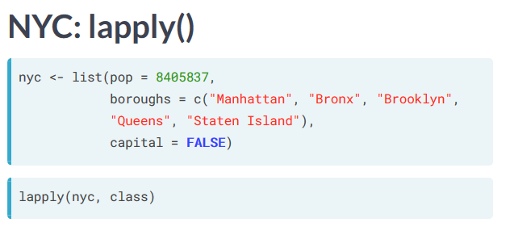
2. Instead of writing a complex for loop, we can use **lapply( ) to apply a function to every element within a list or vector.**
3. Lapply( ) always returns a list, we can use unlist( ) to have it return a vector
4. We can also add additional arguments after the function, such as:

**lapply(oil_prices, multiply, factor = 3)**

1. **Anonymous Functions:** We can define and apply functions using lapply without naming them

**lapply(list, function(x) {3 * x})**

**Sapply (simplify apply):** returns a vector, can only be used when all elements are the same data type, Sapply will also name the values in the vector, if we don’t want this, we do USE.NAMES = FALSE

1. **We can also use sapply to return a matrix when using a function that returns multiple outputs per input**

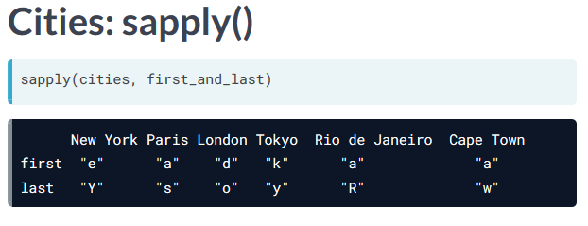

1. Sometimes we can’t use sapply because the function might return different length outputs

Be careful because sapply will return a list instead if simplification is not possible.

**Using vapply:** Apply’s a function over a list or vector, and tries to simplify the result, but it restricts the type of the return value

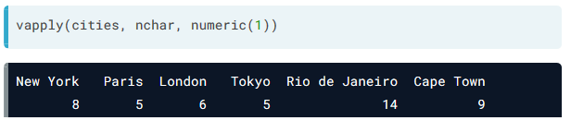

1. We get an error if we try to apply a function with an output is different than what we expect, **this is good because it makes us think about what our function will return rather than blindly using sapply, this is a good sanity check**

**Useful functions in R:**

1. Apply functions: sapply( ), vapply( ), lapply( )
2. sort( )
3. print( )
4. indentical( )
5. **Mathematical functions:**
6. abs( ) absolute vaue
7. sum( )
8. mean( )
9. round( ), can use digits = x to specify how many digits to round to
10. **Function for data structures:**
11. list( ) to create a list
12. seq( ) generates a sequence of numbers such as seq(start_num, stop_num, interval)
13. rep( ) replicates the input, such as rep(vector, times = x) for how many times to replicate it, also each = x, to replicate each value a certain number of times
14. str( ) function inspects the values of the structure of a list
15. is( ) checks the data type such as is.list( ) will return true or false
16. as( ) can covert a data type such as as.list( )
17. unlist( ) will convert a list into a vector
18. rev( ) reverses the elements in data structures
19. append( ) merges vectors or lists
20. **Regular Exapressions:** Sequence of characters and meta characters that form patterns
21. Useful for cleaning data
22. **Grepl function** used to find a character within a string

such as grepl(pattern = “a”, x = animals)

**returns TRUE or FALSE only**

1. To search for things that only start with “a”, use “^a”
2. To search for things that only end with “a”, use “a$”
3. There are many other meta-characters used to search
4. **Grep function:** is like the Grepl function but it **returns the indicies of the matches**
5. **Sub() function** : is like the Greply function but it has replacement argument to replace the first “a” string with an “o” string
6. **Gsub( ) function:** is like the sub( ) function, but it replaces all characters within strings

**Regular Expressions in R:**

1. .* “any character that is matched zero or more times”
2. \\s “matches a space”
3. [0-9]+ matches numbers 0 to 9 at least once
4. [0-9]+) Parenthesis are used to make parts of the matching string available to define the replacement

**Dates and Times in R**

1. Sys.Date( ) tells us what the current date is.
2. This creates a date object that represents dates
3. Sys.time( ) tells us what the current date and time is.
4. The class of sys.time creates a POSIXct object
5. To create dates for other days use as.Date(‘2020-01-01’) for example
6. as.Date(‘year-month-day’)
7. Can also change format = ‘%Y-%d-%m’
8. To add a day to a date string we can do **date + 1**
9. To determine the difference between dates we can do **my_date2 – my_date**
10. Each unit for time object is a second, so **time + 1 adds a second**
11. We can use **unclass( )** to convert a date into numeric
12. It will tell us the number of days since **January 1st, 1970** for example

Supervised Learning with Scikit-Learn

**Supervised learning with Scikit-Learn:**

1. Machine learning is the art and science of giving computers the ability to learn to make decisions from data
2. **Supervised learning** is when the data is labeled, **Unsupervised learning** is when we use don’t label the data
3. **Reinforcement learning** is where software agents optimize behavior given a system of rewards and punishments
4. **Supervised learning:**
5. Predictor variables/features and a target variable
6. We want to predict the target variable, given the predictor variables
7. **Classification:** Target variable consists of categories
8. **Regression:** Target variable is continuous such as price
9. We want to use Supervised learning to automate time-consuming or expensive manual tasks, make predictions about the future, or label data.

**Exploratory data analysis:**

1. Looking at Iris dataset with **4 main features:**
2. Petal length
3. Petal width
4. Sepal length
5. Sepal width
6. Trying to predict **target variable of species:**
7. Versicolor
8. Virginica
9. Setosa
10. Can use **from sklearn import datasets** to get the Iris dataset
11. Can use **plt.style.use(‘ggplot’)** to mimic R’s ggplot
12. To load the dataset use:

**iris = datasets.load_iris( )**

1. We can use **iris.data.shape** to see the shape of the numpy dataframe of features
2. We can use **iris.target.shape** to see the shape of the numpy df of target
3. **We assign the variables to X and Y**

X = iris.data

y = iris.target

1. **We then load them into a Pandas dataframe:**

df = pd.DataFrame(X, columns=iris.feature_names)

1. **We can then plot this into a scatter matrix:**

pd.plotting.scatter_matrix(df, c=y, s=150, marker = ‘D’)

**Classification Challenge:**

1. We want to see how accurately we can predict the already labeled date
2. **K Nearest Neighbors:** We use the closest K neighbors, where whatever point has the most neighbors of a specific type will identify with those types
3. **Decision Boundaries:** Will be determined about where our model decides to use a specific outcome
4. To import KNN use:

**from sklearn.neighbors import KNeighborsClassifier**

1. We then build the KNN model using:

**knn = KNeighborsClassifier(n_neighbors=6)**

1. We then fit the model to train and test data, there also must not be any missing values:

**knn.fit( iris[‘data’], iris[‘target])**

1. We must look at the shape of train and test to ensure they are the same length.
2. We then want to predict a new observation using:

**prediction = knn.predict(X_new)**

**print(‘prediction: {}’.format(prediction))**

We get [110] which represents versicolor for the first two observations and setosa for the last observation.

1. You can use **.drop** to drop the target variable column for a dataframe.
2. You can also use **.values** to change a Pandas DF or series to NP array

**Measuring Model Performance:**

1. Accuracy is a commonly measured, we want to know how well the model will perform on new data.
2. We want to split data into training set and test set.
3. We then compute accuracy on the test set
4. We first import:

**from sklearn.model_selection import train_test_split**

1. We then use the following formula:

**X_train, X_test, y_train, y_test =  
train_test_split(X, y, test_size=0.3, random_state=21, stratify=y)**

1. We use random_state to set the seed to return the same results. It returns 4 arrays, training data, test data, training labels, and test labels. Using stratify guarantees us similar distributions of labels in train and test data.
2. Models with very few hyperparameters will be easy to validate and tun, so you can reduce the size of the validation set.
3. **Cross Validation:** Takes multiple samples of train and test data to avoid overfitting to a specific group of training set.
4. Use **knn.score (X_test, y_test)** to get the accuracy from a model
5. **As K increases, the model becomes less complex and leads to smoother boundaries**

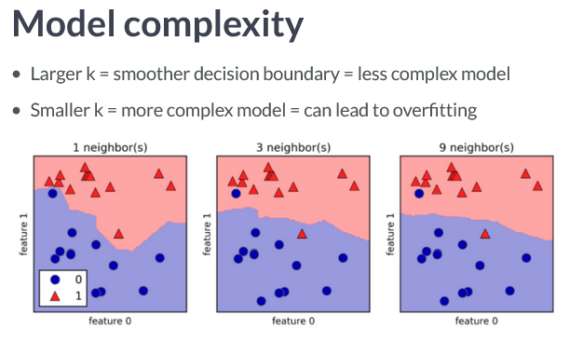

1. We can see the diagram below that details the model accuracy based on N, the ideal number seems to be 9 in this case.
2. **Example code for basic KNN model number classifier**

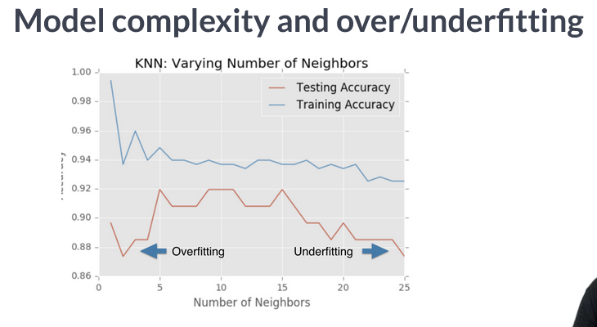

**Example code for basic KNN model with 98% accuracy:**

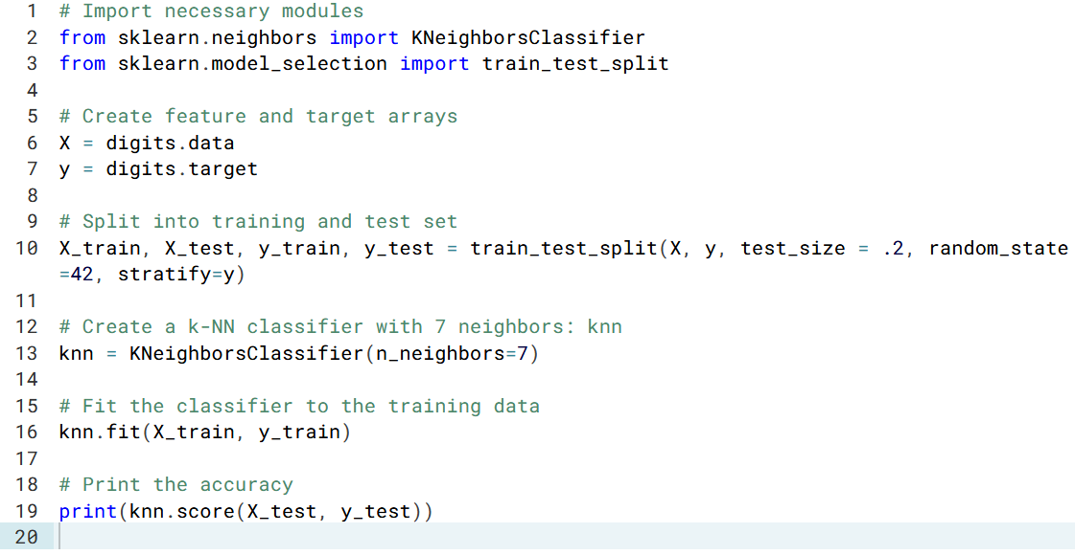

**We can then see how the accuracy varies based on the value we set to K and plot this:**

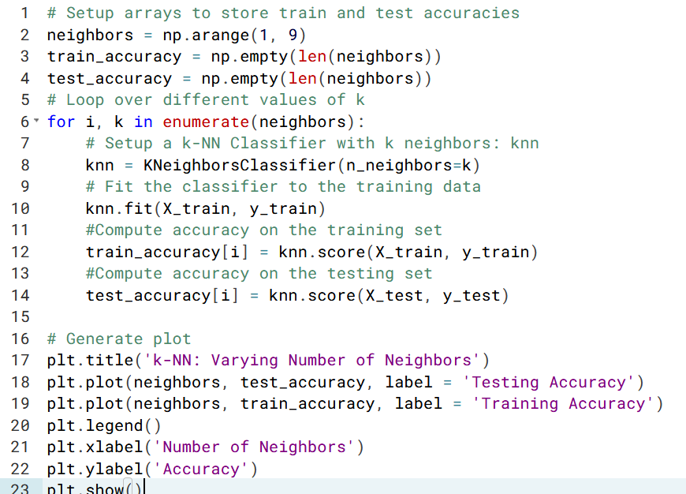

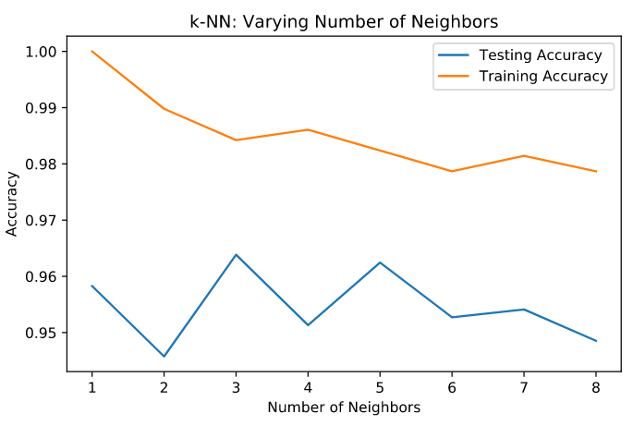

**Introduction to Regression in Sk learn:**

1. Will be using boston housing data to predict housing prices.
2. In the first part we drop the target, then for the Y we keep only the target:

**X = boston.drop(‘MEDV’, axis=1).values**

**y = boston[‘MEDV’].values**

1. We want to try to predict price from a single feature, rooms, so we slice that column:

**X_rooms = X[: , 5]**

1. To reshape numpy arrays into two dimensional, we do:

**y = y.reshape(-1, 1)**

**X_rooms = X_rooms.reshape(-1, 1)**

1. To fit a regression model, we use:

**import numpy as np**

**from sklearn.linear_model import LinearRegression**

**reg = LinearRegression( )**

1. We then fit the variables to the regression:

**reg.fit( X_rooms, y)**

**prediction_space = np.linspace(min(X_rooms), max(X_rooms)).reshape(-1, 1)**

1. You must reshape a numpy array if you’re only working with 1 feature.
2. **As seen in the code below, reshaping an numpy array changes the shape from (139, ) a one-dimensional array to (139, 1), a two dimensional array:**

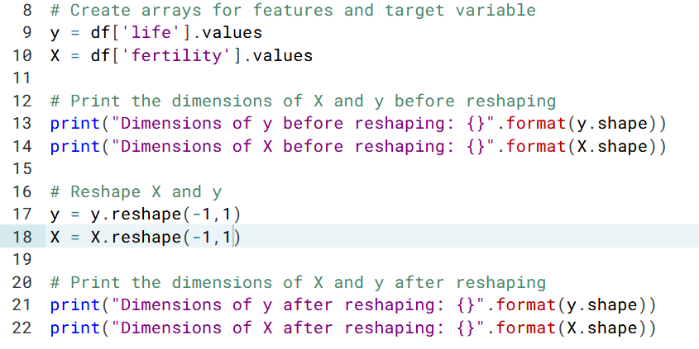

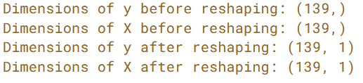

**Basics of Linear Regression**

1. Ordinary Least Squares (OLS): minimizes the sum of squared errors of linear regression
2. To implement regression in sklearn:

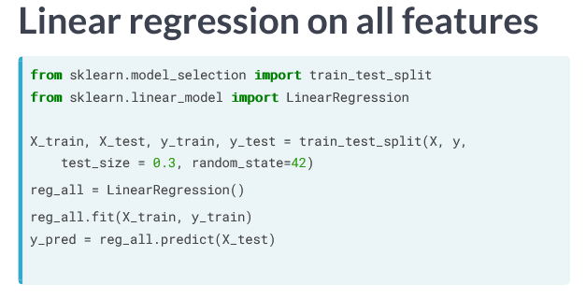

1. Generally you will never use linear regression out of the box, instead we will use regularized linear models.
2. Use **from sklearn.metrics import mean_squared_error**

To calculate mean squared error for the model

1. **To calculate R squared use .score(X_test, y_test)**

**Cross Validation:** If you’re computing R squared on the test set, it’s dependent on the test data.

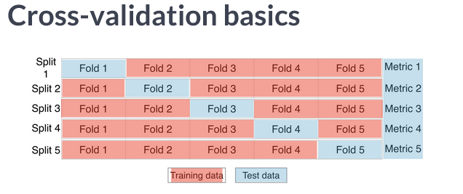

We can split the data into 5 folds, each fold representing a different slice of test data. As you do more folds, it’s computationally dependent

1. To perform cross validation:

**from sklearn.model_selection import cross_val_score**

1. Then we do:

**cv_results = cross_val_score(reg, X, y, cv=5)**

1. We then take the mean R squared of the results:

**np.mean(cv_results)**

**Regularized Regression:** When we have too many coefficients (X-variables), it can lead to overfitting, so we penalize large coefficients.

1. **Alpha** is like a parameter that determines the complexity of the model, we add alpha within the sum eqation to OLS, which then is fed into the loss function. We have to tune alpha in order to get the best fit.

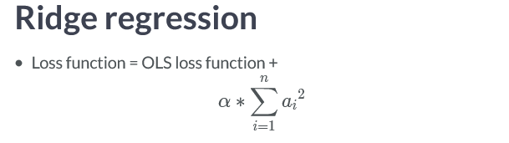

1. To implement regularized regression, we use:

**from sklearn.linear_model import Ridge**

**ridge = Ridge(alpha=.1, normalize = True)**

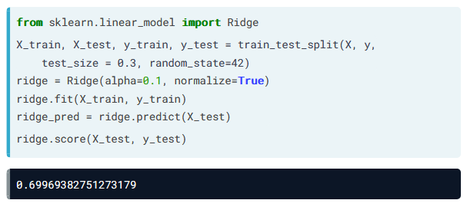

**Lasso regression:** Similar to Ridge regression except we add the absolute value multiplied by alpha.

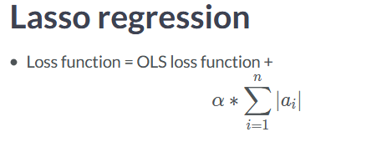

1. We can use Lasso to find important features within a dataset because coefficients are reduced to 0.
2. To implement Lasso we use:

**from sklearn.linear_model import Lasso**

**lasso = Lasso(alpha=.1)**

**lasso_coef = lasso.fit(X, y).coef_**

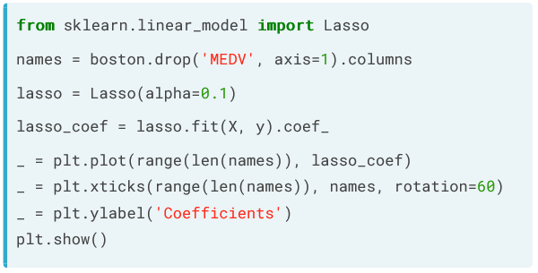

**We can then see which coefficients are the most import, where rooms of the house is the significant variable associated with house prices.**

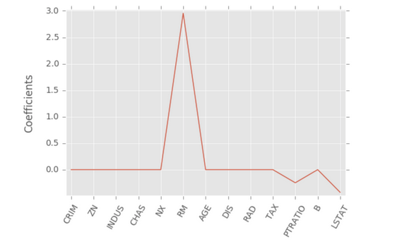

**L1 Norm:** Penalizing based on absolute value of coefficients, as in Lasso

**L2 Norm:** Penalizing based on square root of coefficients, as in Ridge regression

**Fine Tuning your Model**

1. **Classification you can use accuracy:** But accuracy is not always a useful, such as spam classification that is 99% accurate, but 1% of emails are spam
2. **Class Imbalance:** When there are a lot more of real emails rather spam emails.
3. **Confusion Matrix:** Shows the distributions of true/false positives and negatives

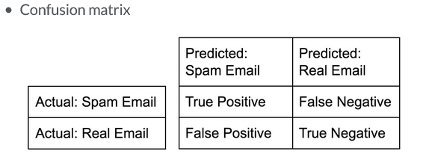

1. **Confusion Matrix Accuracy:** TP + TN / (TP + TN + FP + FN)
2. **Precision:** TP / (TP + FP)

“Percentage of results that are relevant”

1. **Recall:** TP / (TP + FN)

“Percentage of total relevant results correctly classified by algorithm”

1. **F1 Score:** 2 * (Precision * Recall) / (Precision + Recall)

“Harmonic mean of precision and recall that attempts to balance the tradeoffs of each metric”

1. **Support:** The number of Republicans or Democrats in the test set on which the classification report was computed.
2. **Confusion Matrix Code:**

confusion_matrix(y_test, y_pred)

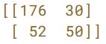

1. **Classification Report:**

classification_report(y_test, y_pred)

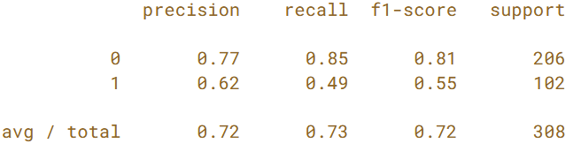

**Logistic Regression and ROC curve**

1. Logistic regression is used in classification problems.
2. Can be used in binary classification, it produces a linear decision boundary

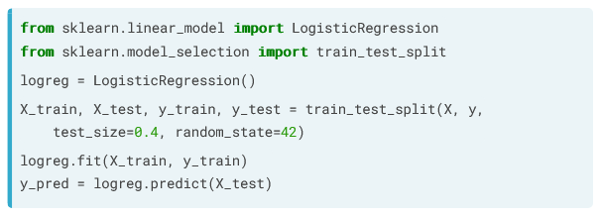

1. **Receiver Operator Characteristic (ROC) Curve:**

All the different combinations of false positives and negatives that yield and overall P value.

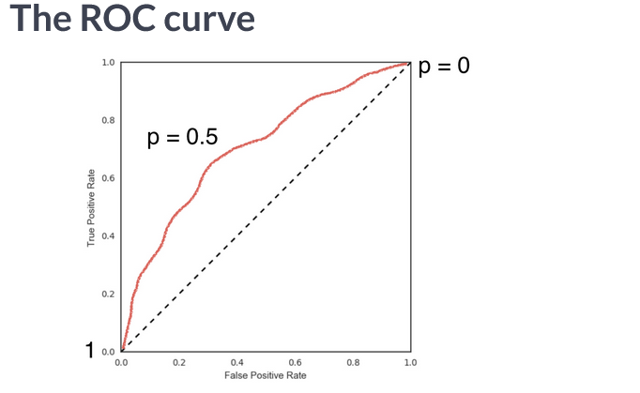

We can visualize the ROC curve using the code below:

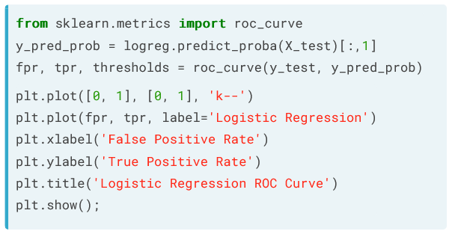

**Area under the ROC curve (AUC):**

1. The larger the area under the ROC curve, the better the model is.
2. We have to **import roc_auc_score from sklearn.metrics**

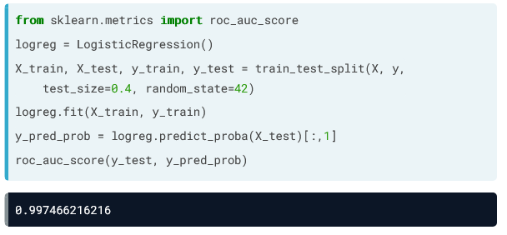

**Alternatively, we can use the roc_auc score with cross validation:**

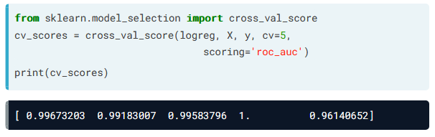

**Hyper-parameter Tuning**

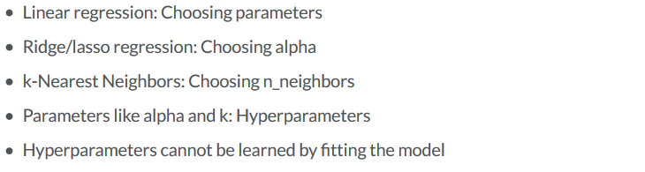

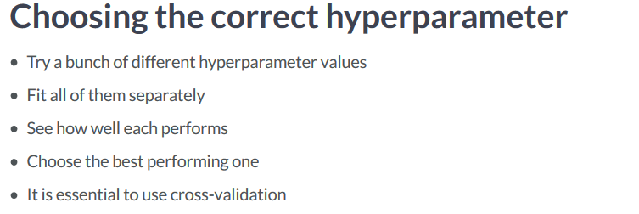

**Imagine we have two hyper-parameters, we can use GridSearch CV to find the best hyper-parameter.**

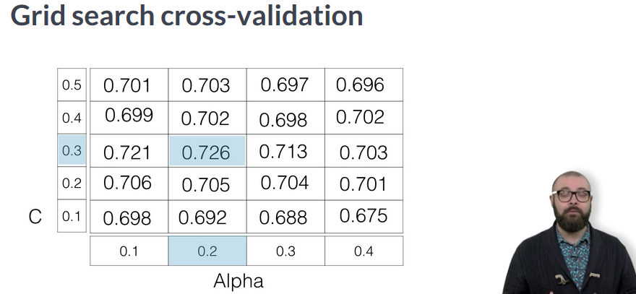

**The area below is how we apply GridSearchCV to tune hyper-parameters**

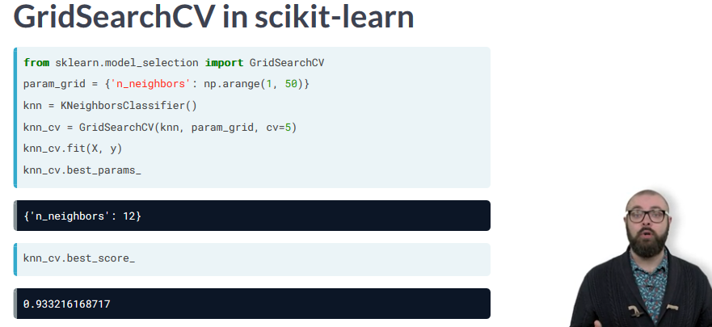

**Logistic Regression Hyper-Parameters:**

1. Alpha parameter, a, determines the complexity of the model.
2. Regularlization Parameter, C, which controls the inverse of the regularization strength. A large C can lead to an overfit model, whereas a small C can lead to an underfit model.

**Using RandomizedSearchCV over GridSearchCV**

1. GridSearchCV can be computationally expensive if searching over large hyper-parameter space, better to use RandomizedSerachCV instead

**Hold-out set for final evaluation**

1. After performing testing to tune hyper-parameters, we want to see how the data will perform on a never before seen model?
2. **Dev Set:** Used to train hyper-parameters, separate from train and test data.

**Elastic Net penalty for Logistic Regression**

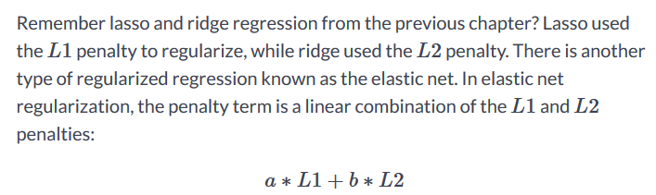

**Preprocessing Data**

1. You have to convert categorical features into numerical features, such as 0 or 1 for male or female
2. We can convert all of the features into **Dummy Variables**, which have a binary variable representing whether each feature is present.
3. To **encode dummy variables:** We import pandas, load data into df, and use .get_dummies( )

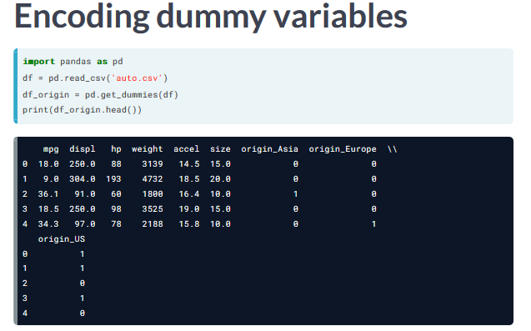

We can also use the **.fit( ) method** to fit the data directly.

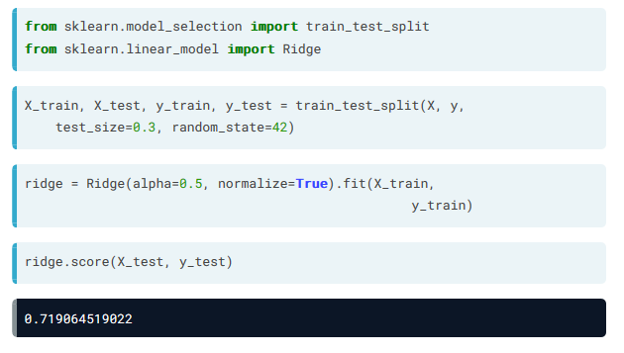

**Handling Missing Data**

1. Need to check the data to make sure there is no missing data
2. **First check df.info( )**
3. Then look for 0s, question marks, etc.
4. We can use **df.dropna( )** to drop all missing data values
5. We could also **impute** missing data to make an educated guess, by calculating the mean of non-missing entries and replace the missing values with the mean
6. We could also replace missing values by randomly sampling from the mean and std dev to simulate more realistic values
7. We want to transform our data and then fit a model to it

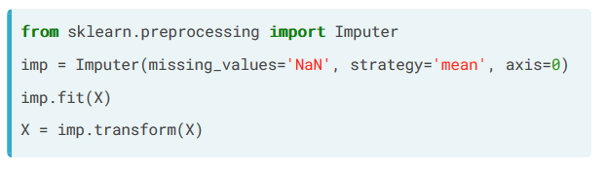

1. We can do both of these things at once using the **Pipeline object**

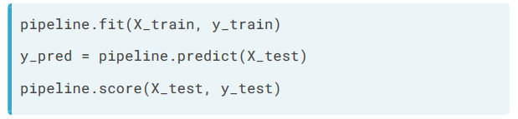

1. We can use **df[ df == ‘?’ ] = np.nan** to convert missing numbers to NaN
2. We can then use **df.dropna( )** to drop these values.

**Centering and Scaling Data**

1. Use **df.describe( )**  to check out the ranges of features in the dataset
2. **If you have features on much larger scales, it can unduly influence model, we want features to be on a similar scale.**
3. To scale features, we import from sklearn.preprocessing

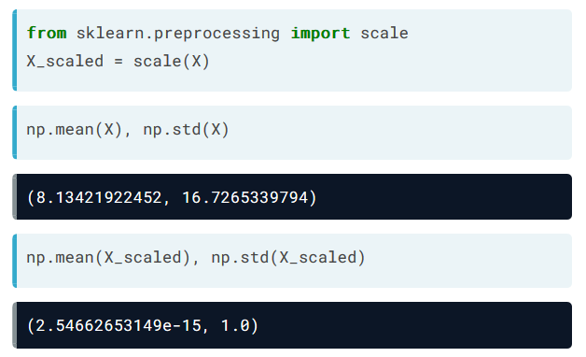

1. We can also scale within a pipeline, **scaling can have a significant effect on accuracy:**

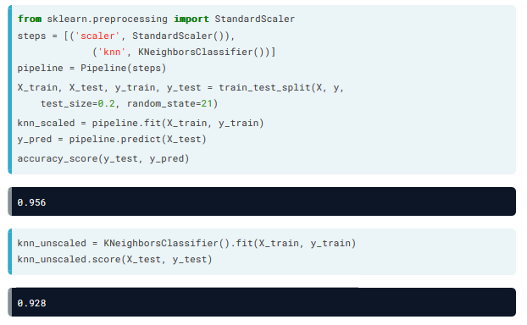

We can also incorporate cross validation into our supervised learning pipeline.

1. We can use GridSearchCV to find the best parameters in addition to using scaling

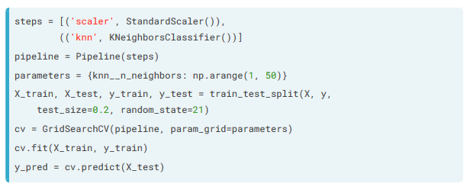

Writing Functions in R

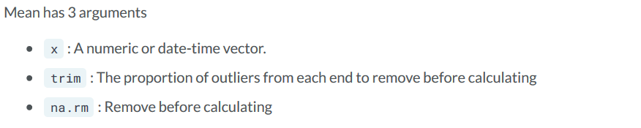

Sometimes it can be hard to remember what each variable is, better to **provide names for rare arguments, but don’t provide your name for common arguments.**

To select specifc columns from a dataset use:

**Functions prevent writing redundant code and help you to avoid errors.**

1. Reduces workload and helps you to avoid errors.
2. Makes it easier to reuse code and share functionality with others.

**Converting scripts to functions:**

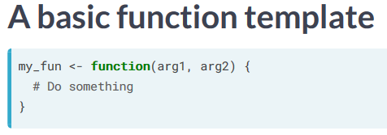

Functions are a type of variable, so you assign functions just like anything else.

You could just put the file names in a list and then have the function run on each file.

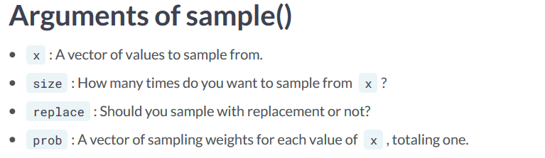

Functions perform actions like verbs. You want to make sure you name functions well, unlike lm( ) which stands for “linear model”, better name would be “run_linear_regression( )”

Use **args(“function name”)** to get the main arguments for a function.

1. **Data arguments:** tell you what to perform the function on
2. **Detail arguments:** tell you how to perform a function

**We could rewrite the lm function using another function to fix errors with lm( )**

1. Such as the data argument doesn’t come first in lm( )
2. Therefore, it doesn’t work in pipelines.

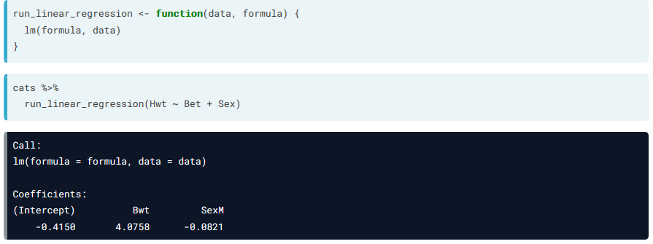

**Default Arguments**

1. You can set default arguments for functions in R

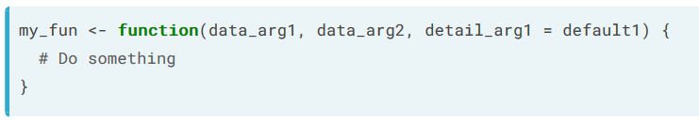

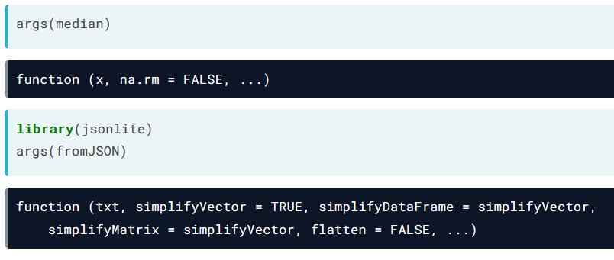

Some functions use NULL defaults:

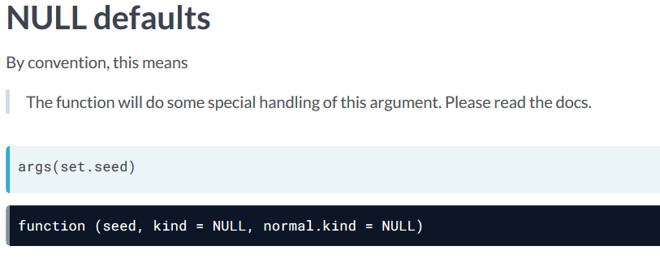

**Passing Arguments Between Functions**

… argument allows you to accept any other arguments in calc geometric mean

If the signature of inner function changes, code will still work, but too much flexibility could break other people’s code rather than breaking your code.

It depends on how much you trust an inner function and how stable you want your signature to be.

Machine Learning with Tree Based Models

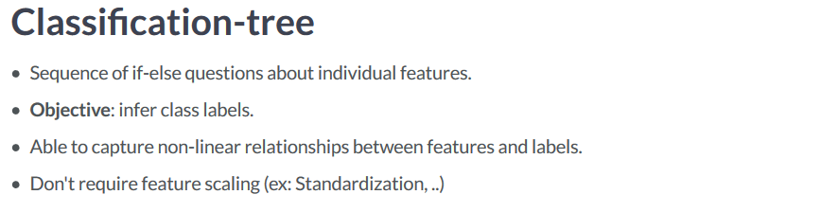

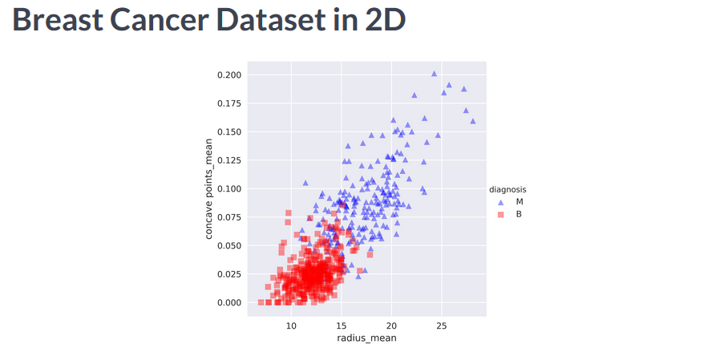

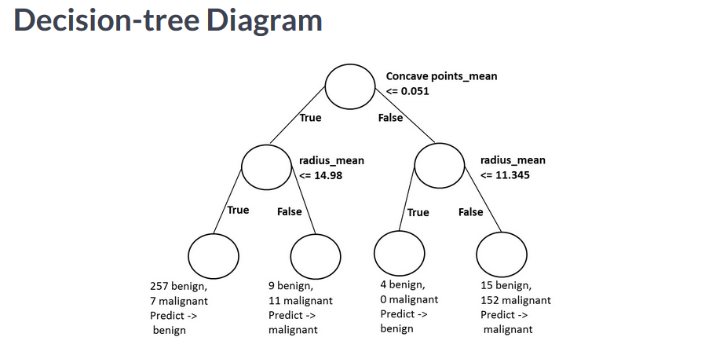

We can fit a classification tree using **SkLearn**

We set **stratify to y** to make sure train and train sets have same proportion of class labels as unseen data.

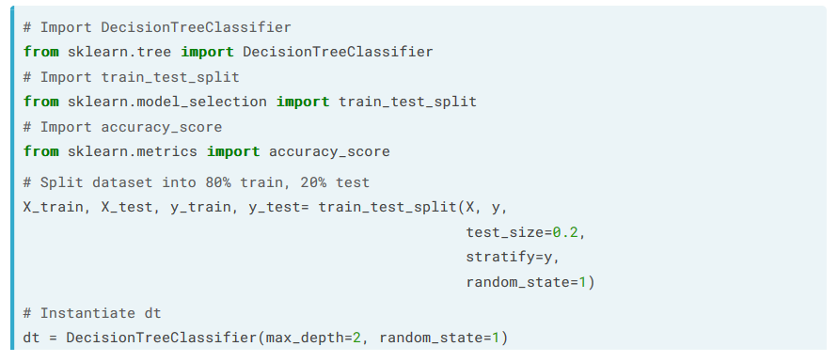

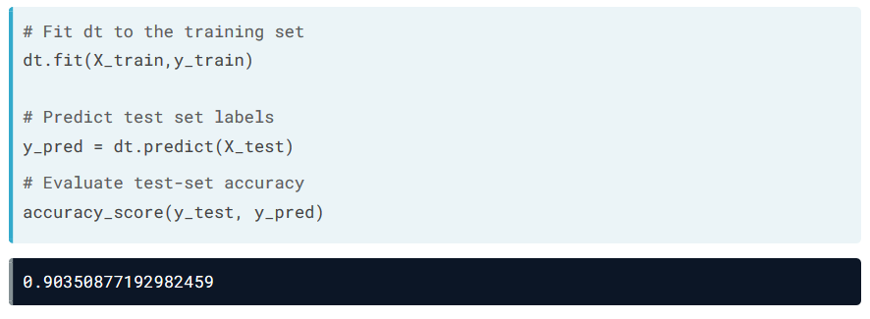

**Classification Tree** produces rectangular decision tree boundaries.

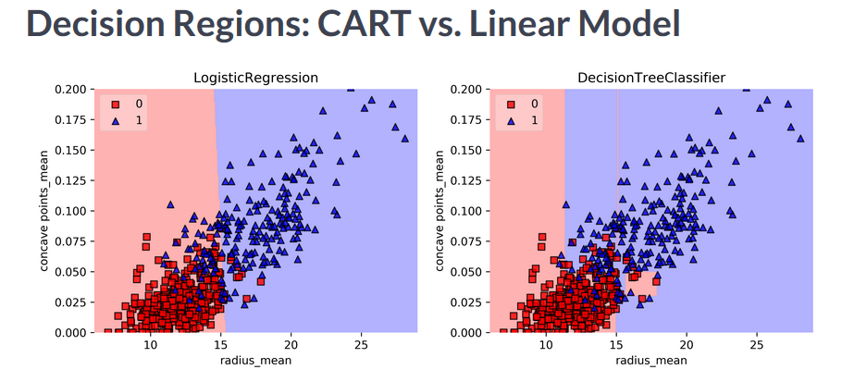

Classification Tree learning

**Decision Tree:** Data structure consisting of a heirarcy of nodes

a) **Node:** question or prediction

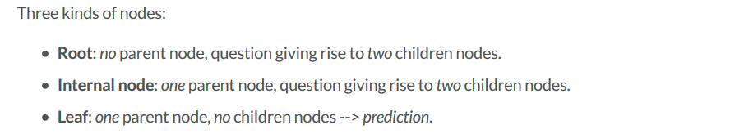

The decision tree wants to maximize information split between two nodes, using the following formula:

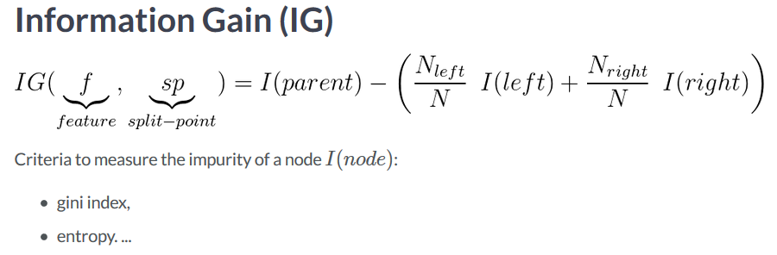

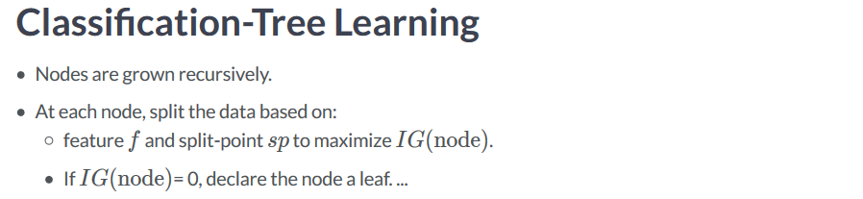

Decision Tree for Regression

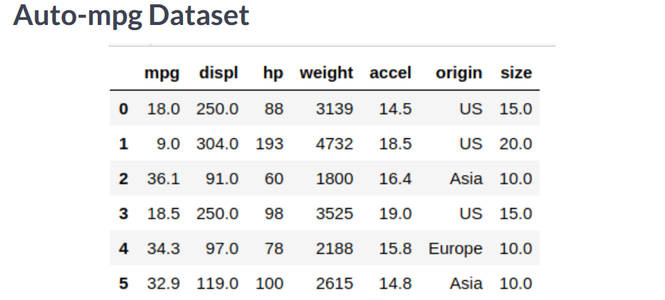

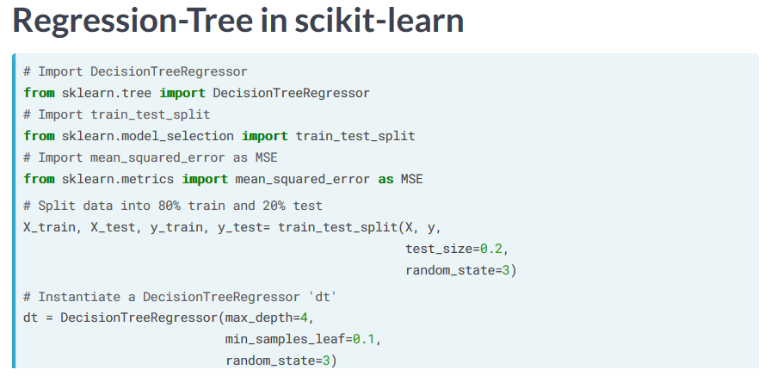

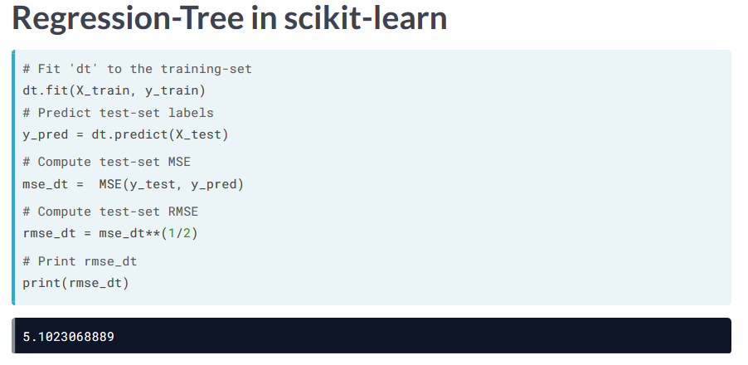

Regression-Tree tries to produce a tree where, on average, the values within a leaf are closest to the mean within that leaf.

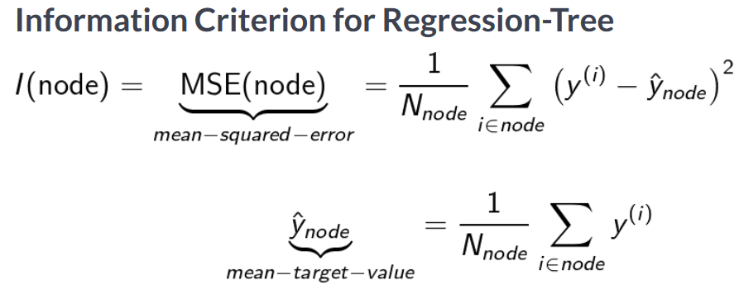

The predicted value is based on the mean within a particular leaf.

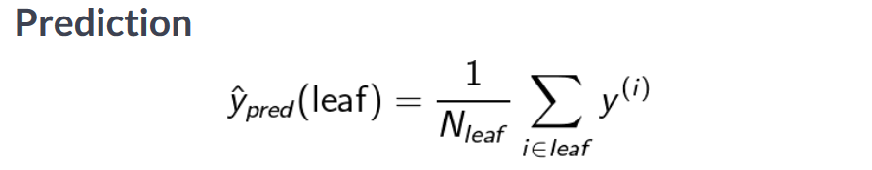

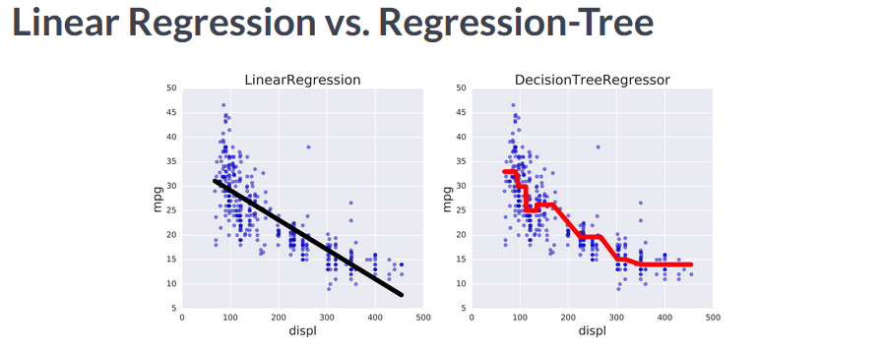

**RMSE** measures on average, how much the model’s predictions differ from the actual labels

Bias-Variance Tradeoff

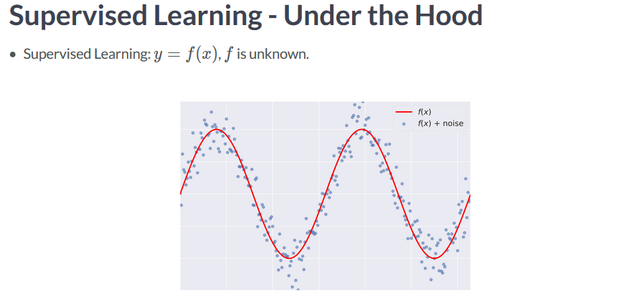

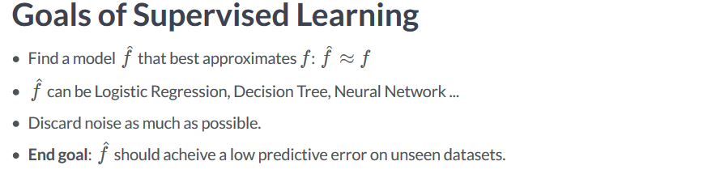

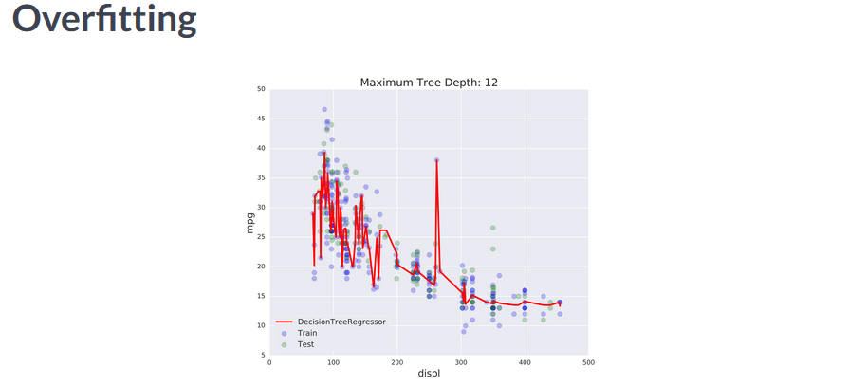

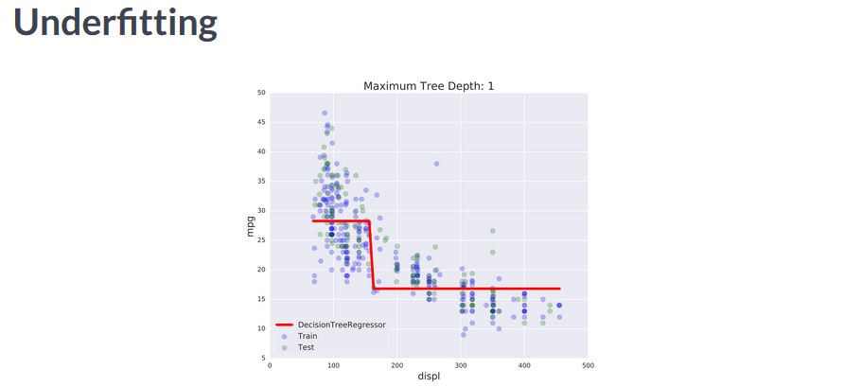

**We want to tune the maximum tree depth to give us the lowest RMSE.**

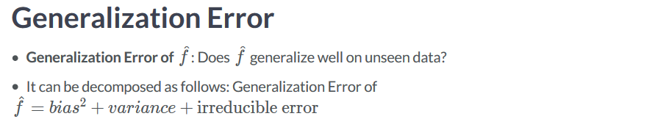

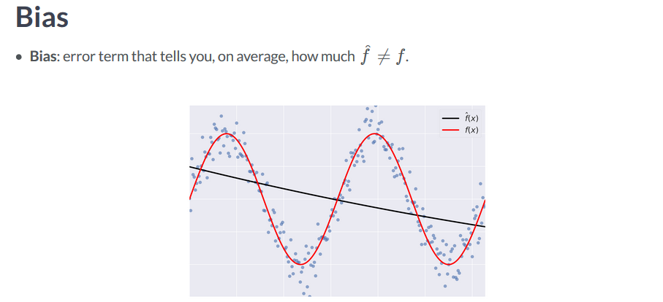

**High bias models lead to underfitting**

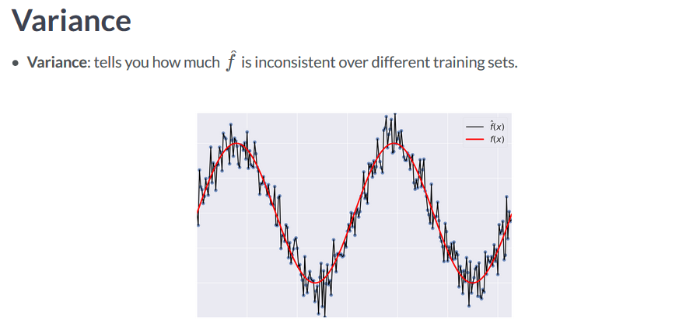

**High variance models lead to over-fitting**

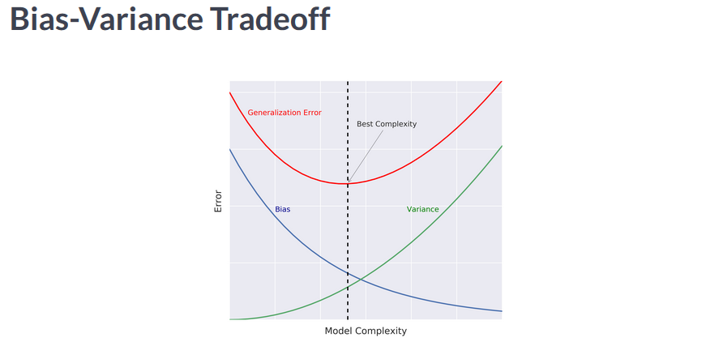

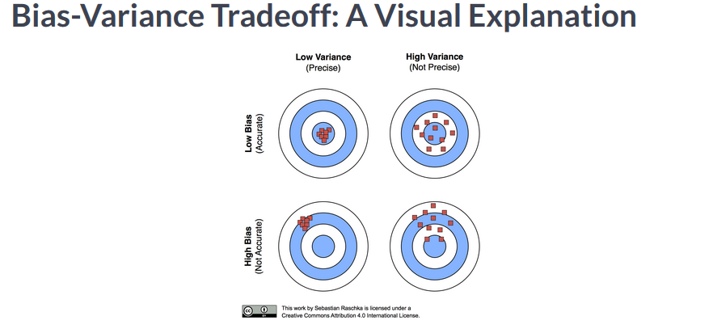

Diagnose Bias and Variance Problems

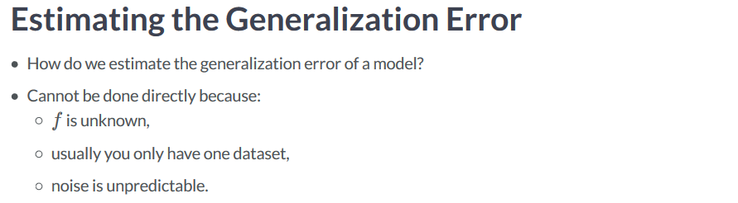

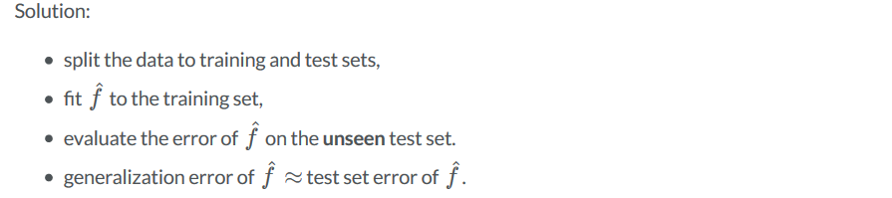

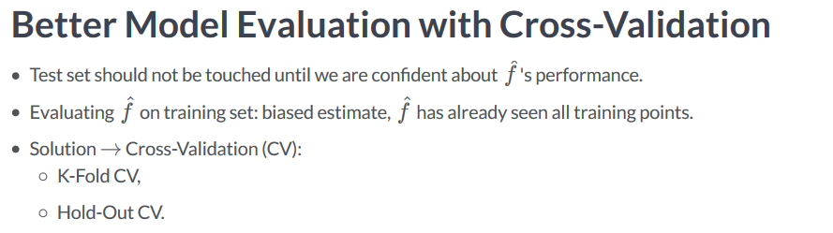

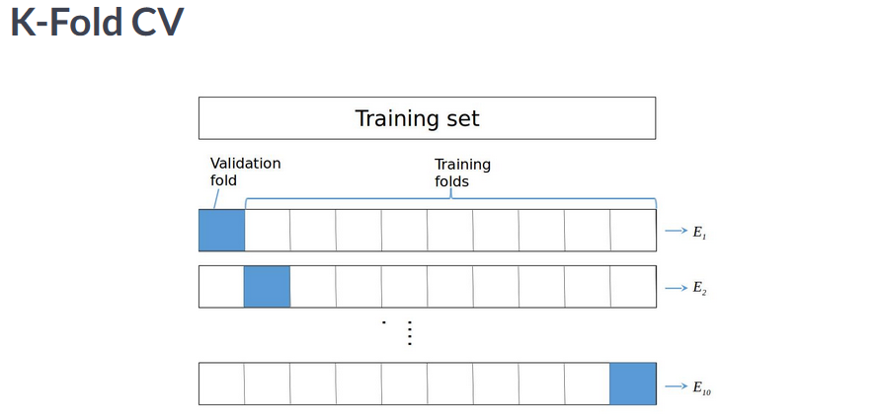

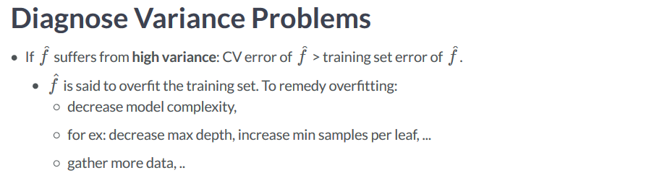

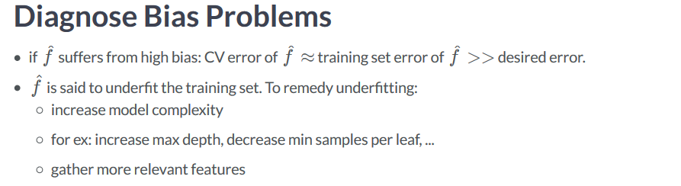

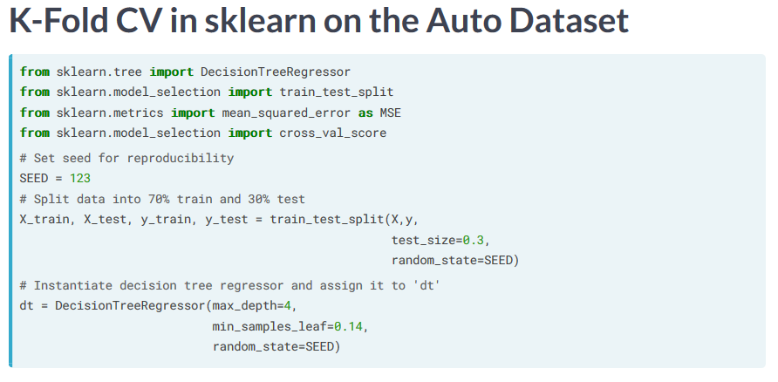

**n_jobs is set to -1 to exploit all available CPUs and computation**

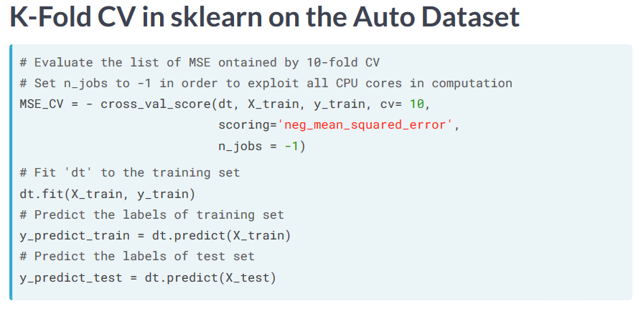

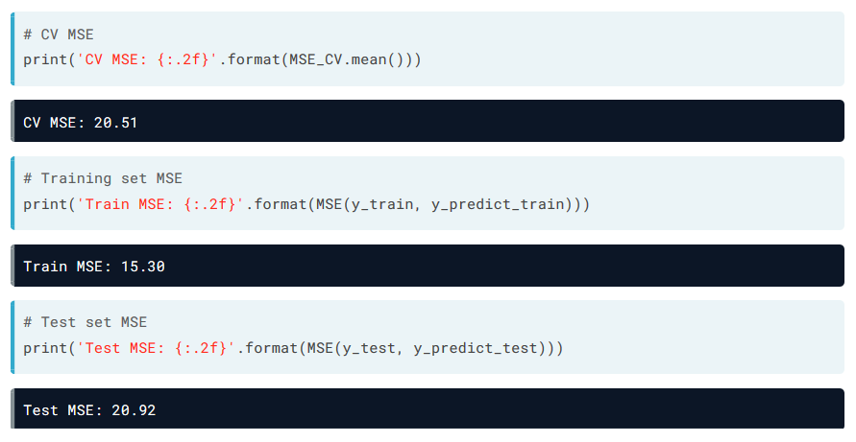

Ensemble Learning

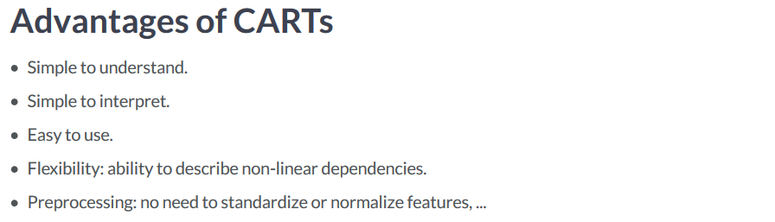

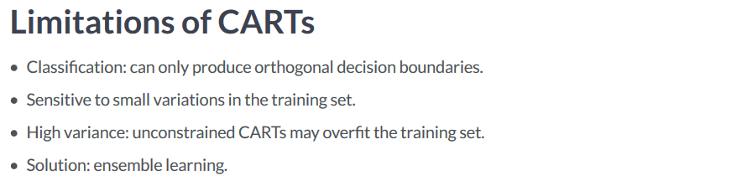

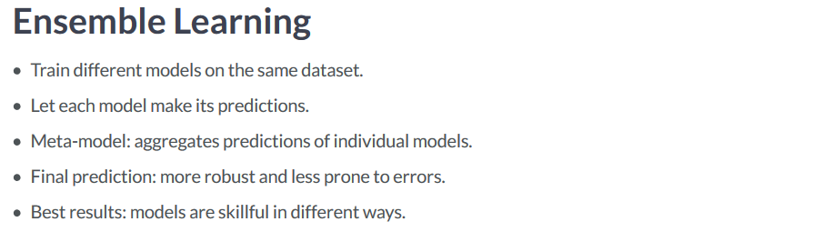

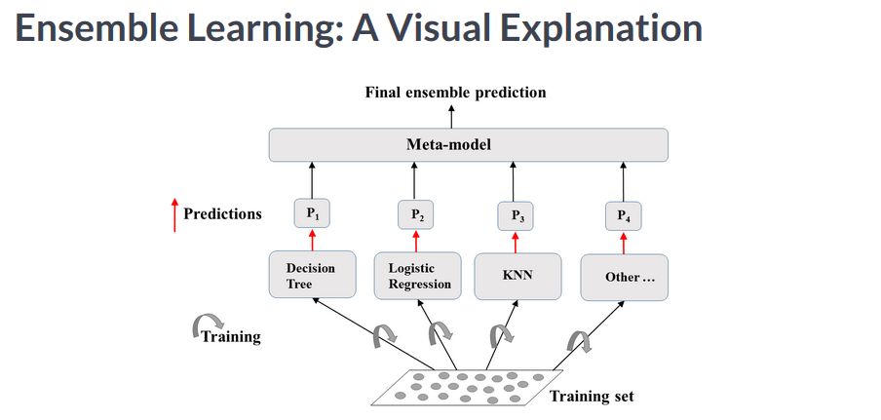

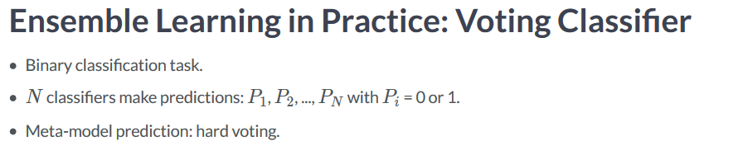

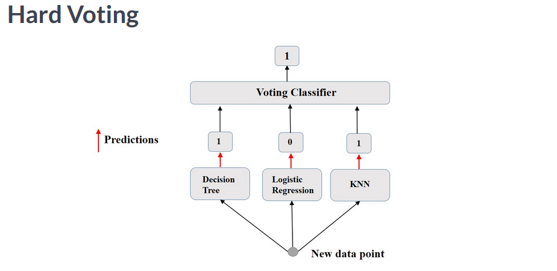

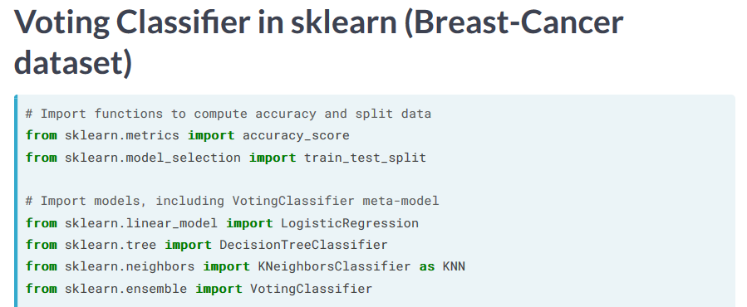

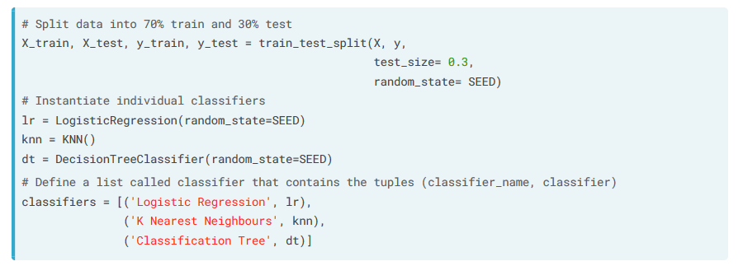

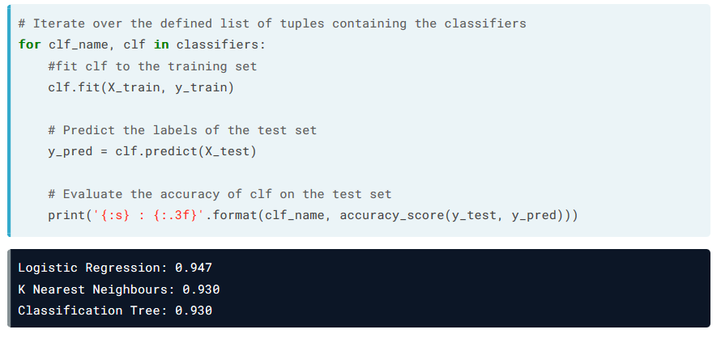

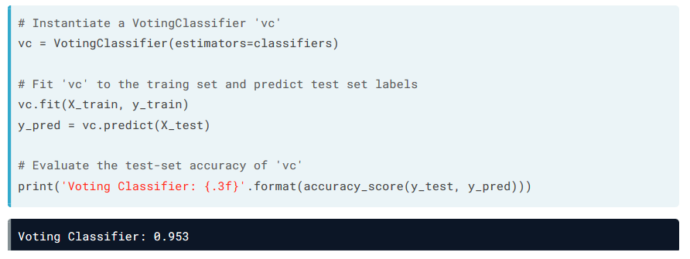

Bootstrap Aggregation, also known as Bagging

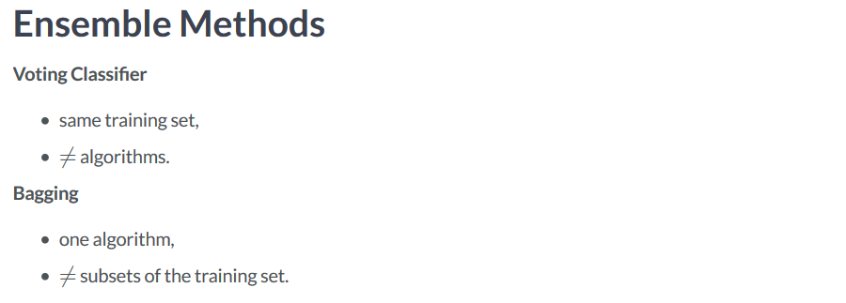

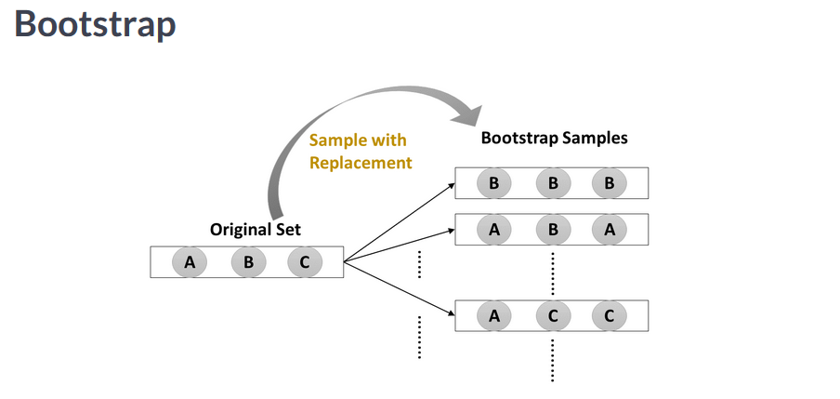

**In Bootstrap, random samples are drawn from the training set:**

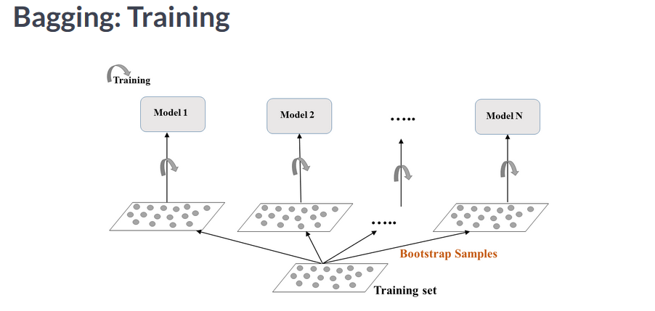

**These samples are then fed to the same algorithm for training.**

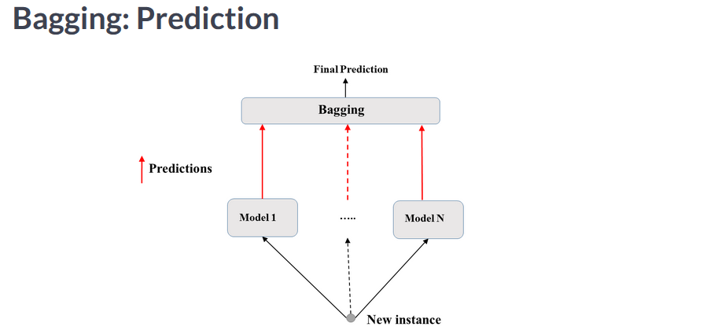

**In classification, the final predication is made for majority voting with classification or through averaging with regression.**

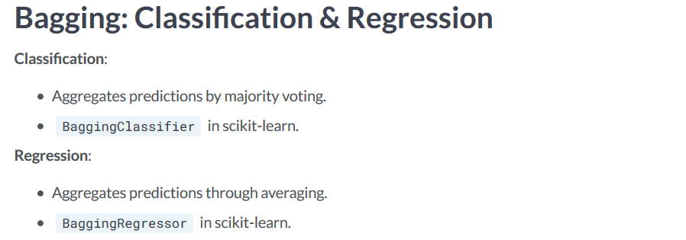

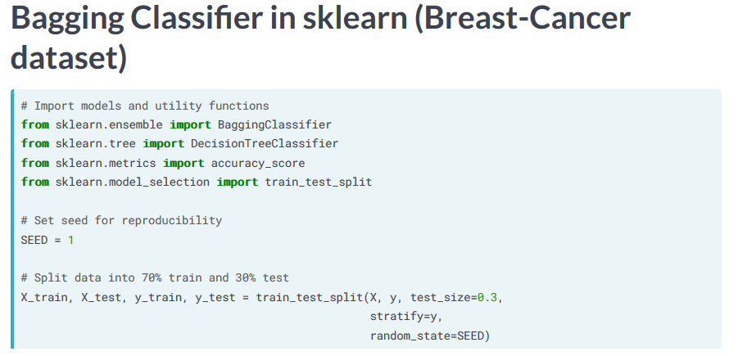

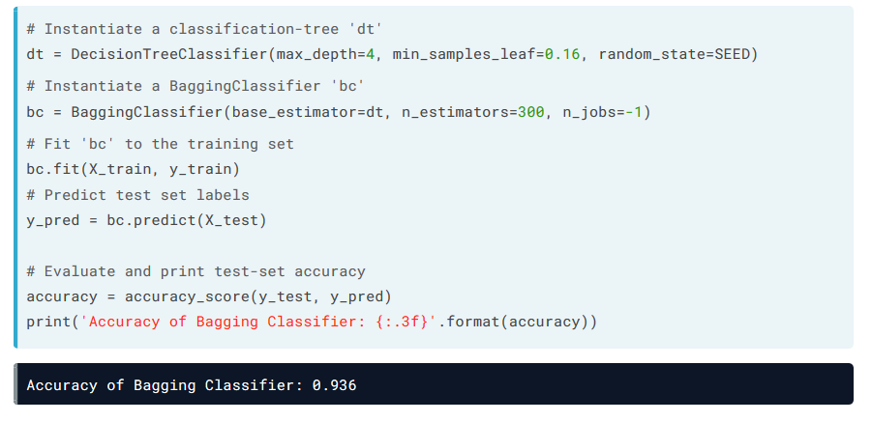

**Out of Bag Evaluation**

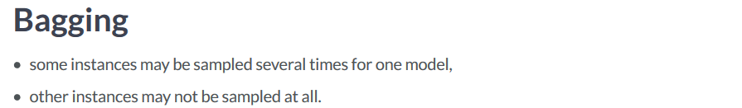

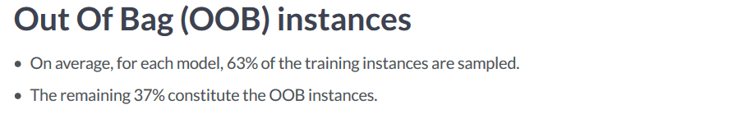

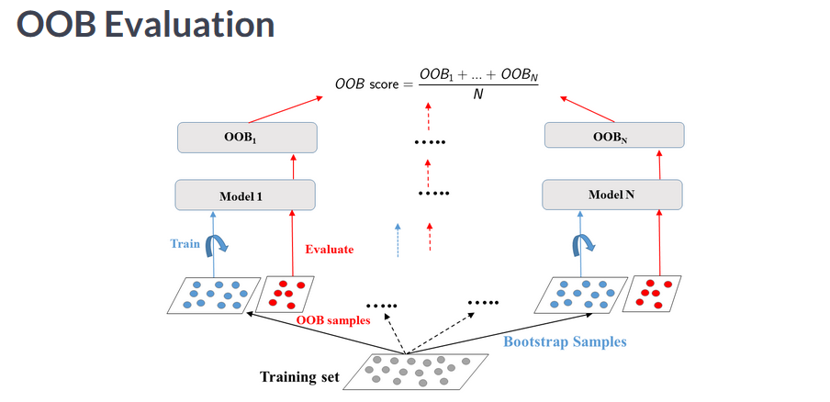

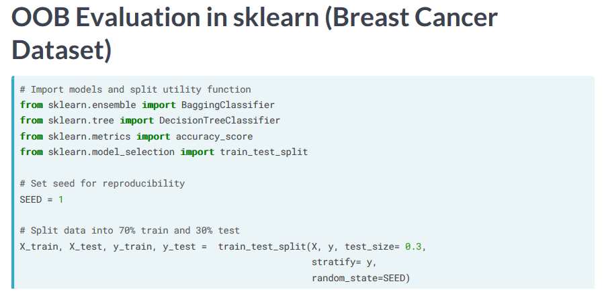

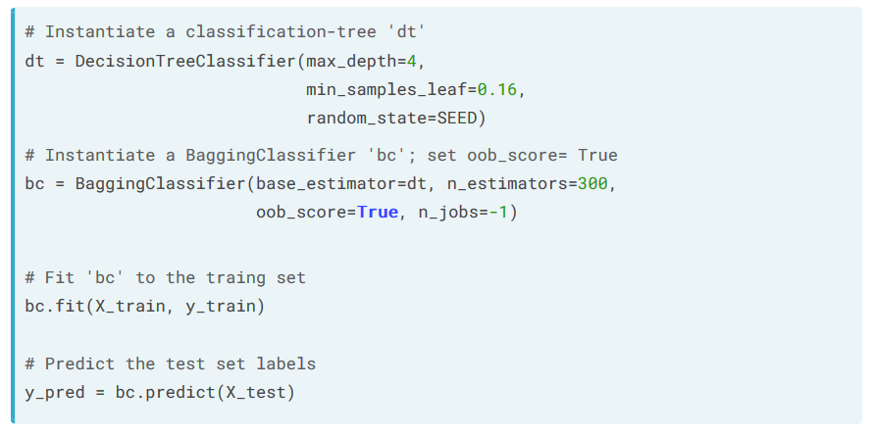

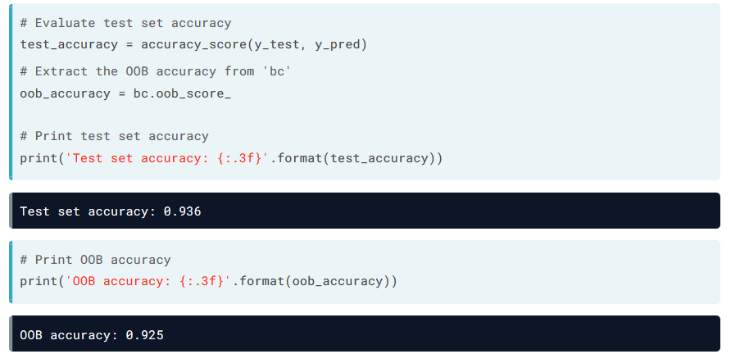**OOB accuracy can be another way to obtain accuracy from unseen data without performing cross validation.**

Random Forests

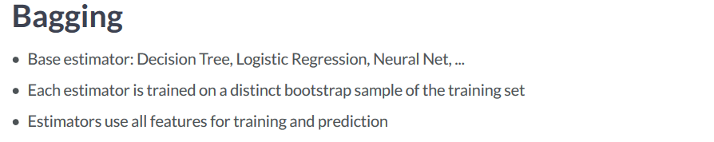

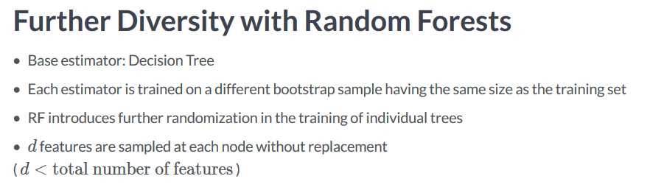

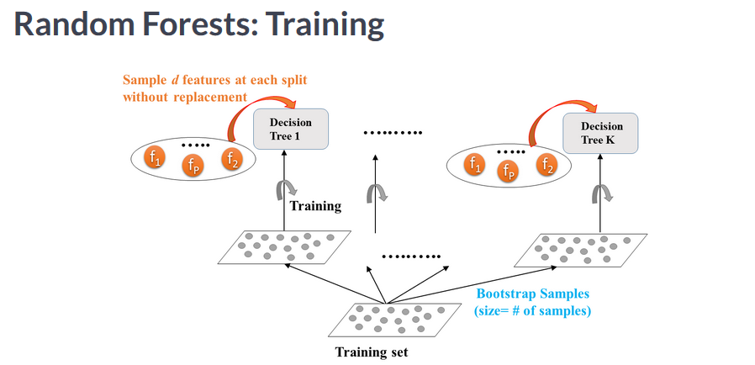

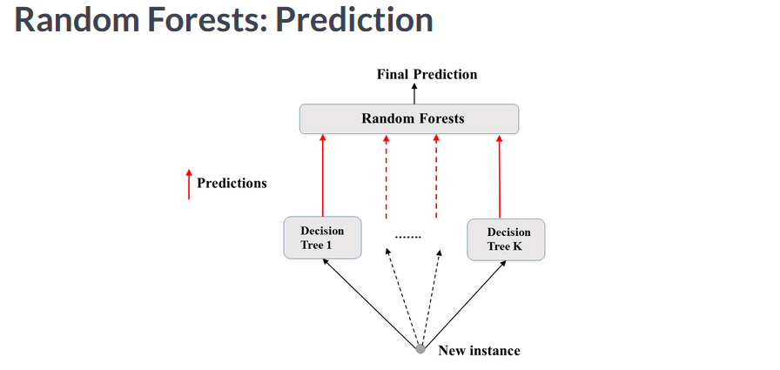

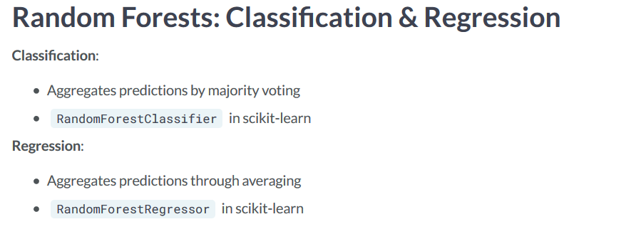

**You can use a Pandas series along with the feature importance meathod of SKlearn and graph the importance of certain features:**

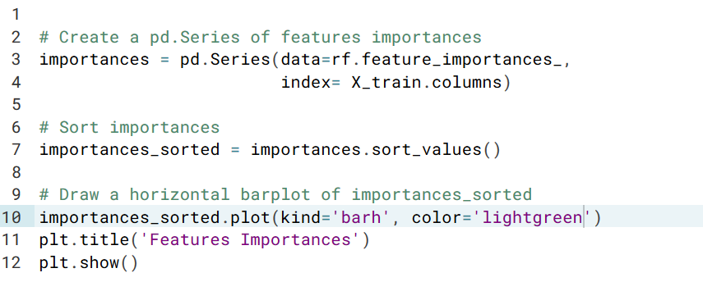

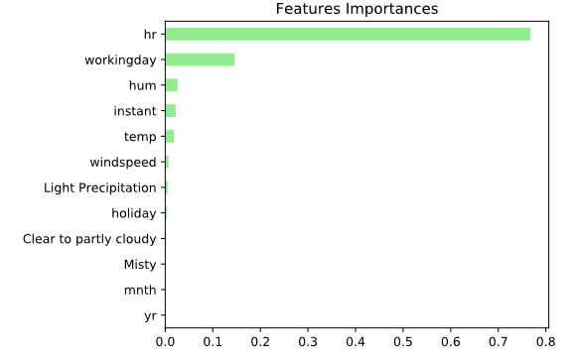

**Adaboost**

**Boosting refers to an ensemble method where various predictors are trained and each predictor learns from the errors of its predecessors.**

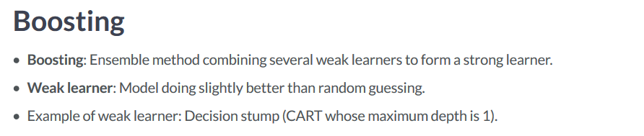

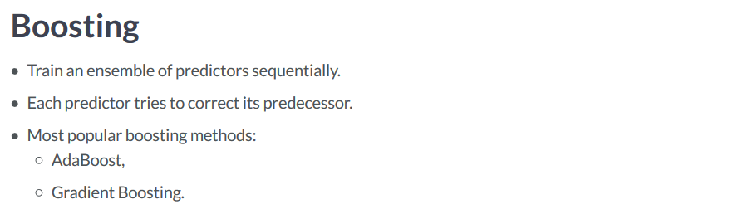

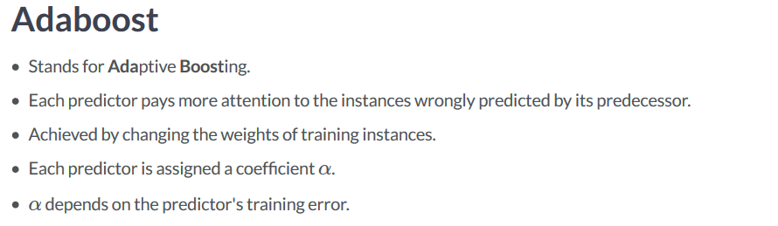

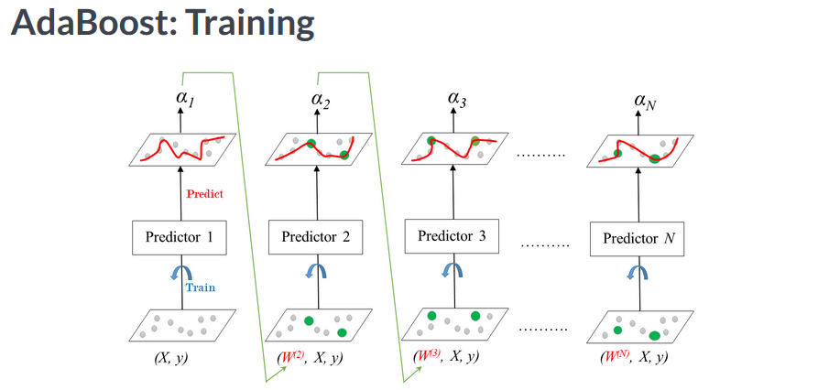

**Predictor 1, produces a coefficient Alpha, and then assigns specific Weights to the errors, which forces the next model to pay more attention to the errors.**

**Eta represents the learning rate**

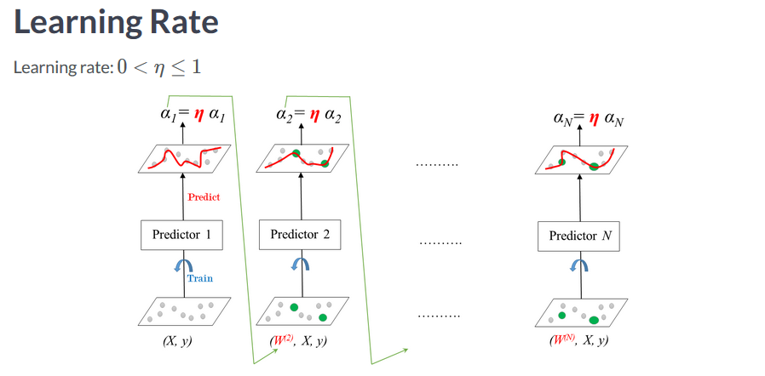

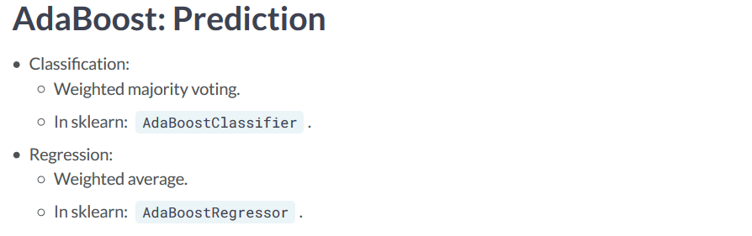

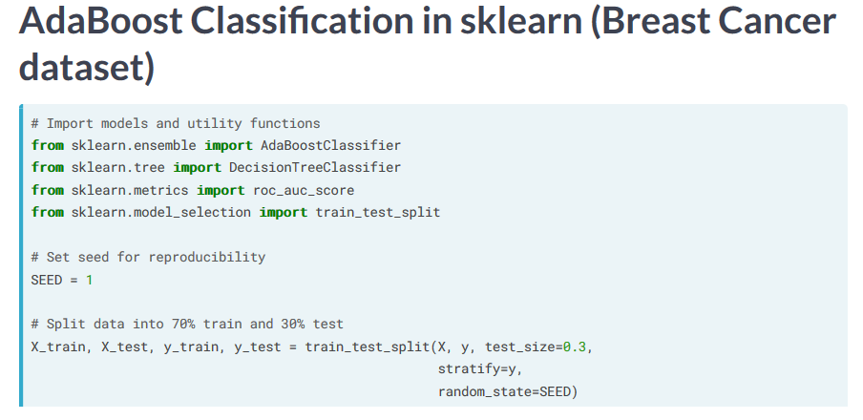

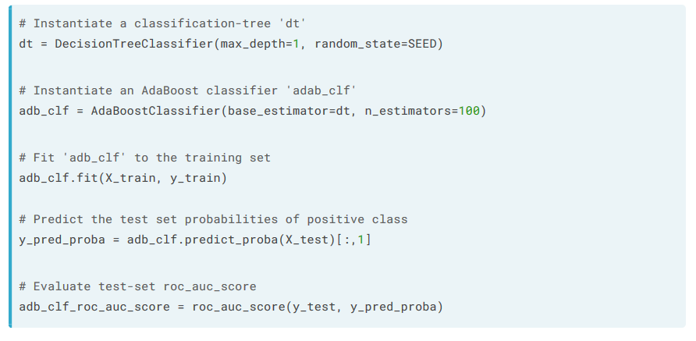

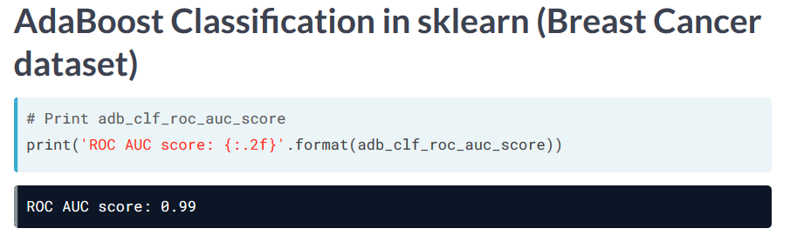

**Gradient Boosting (GB)**

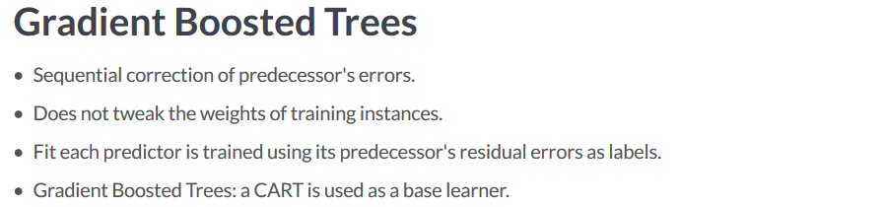

**Each tree is trained on the residual errors of the previous trees. This is repeated until all of the N trees in the ensemble are trained.**

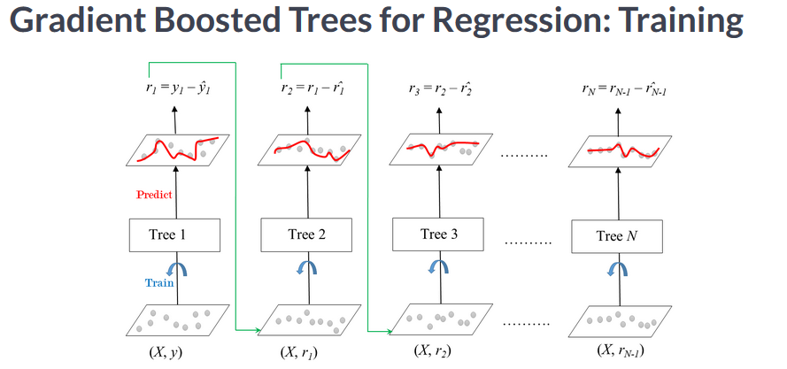

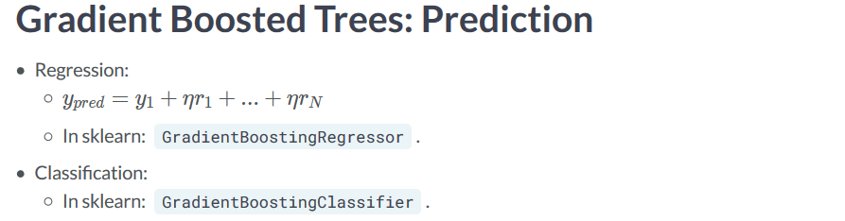

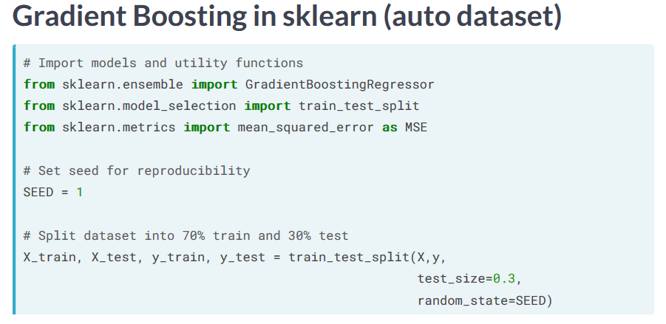

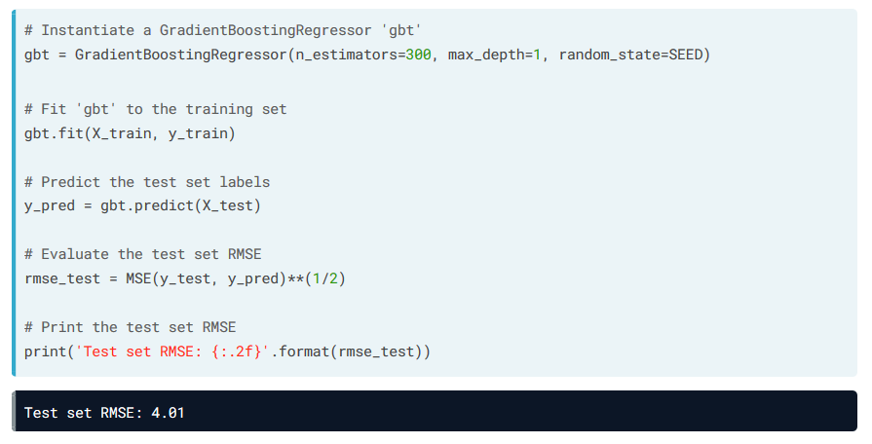

**Stochastic Gradient Boosting (SGB)**

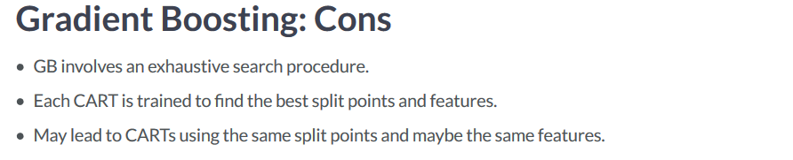

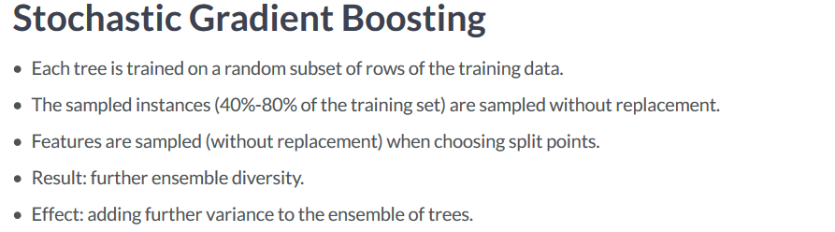

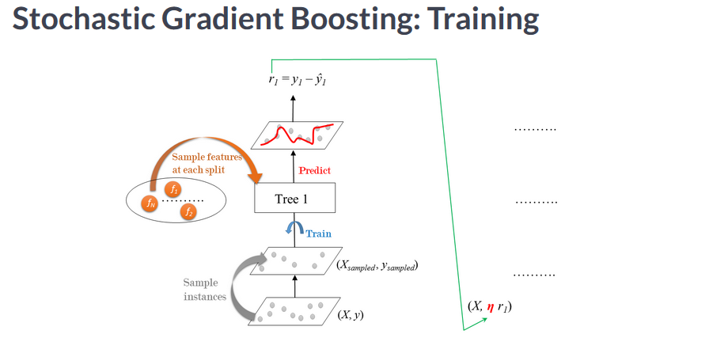

**Residual Errors are multiplied by the learning rate Eta until all of the trees are used.**

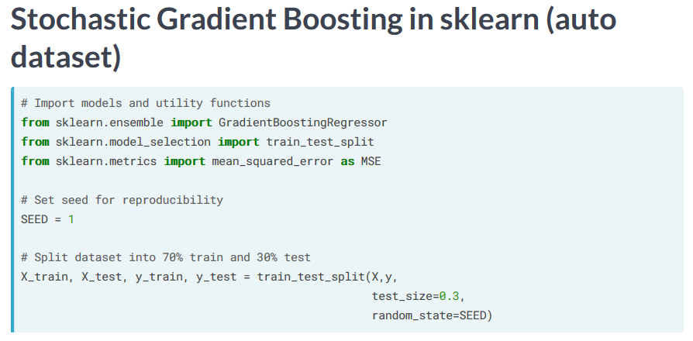

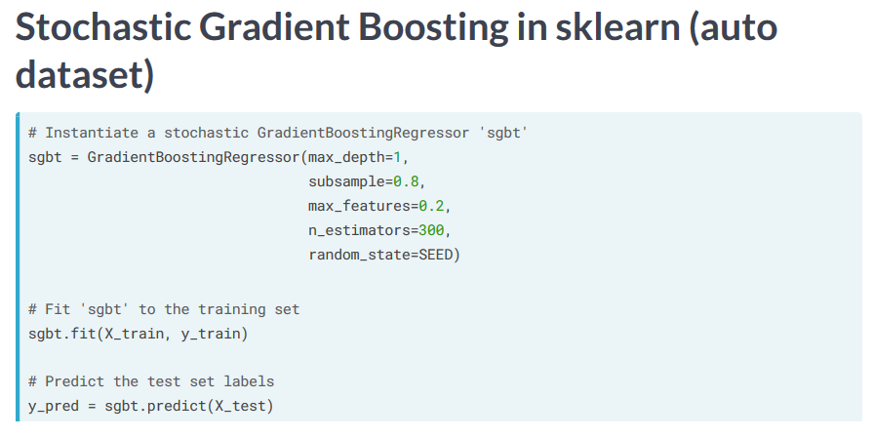

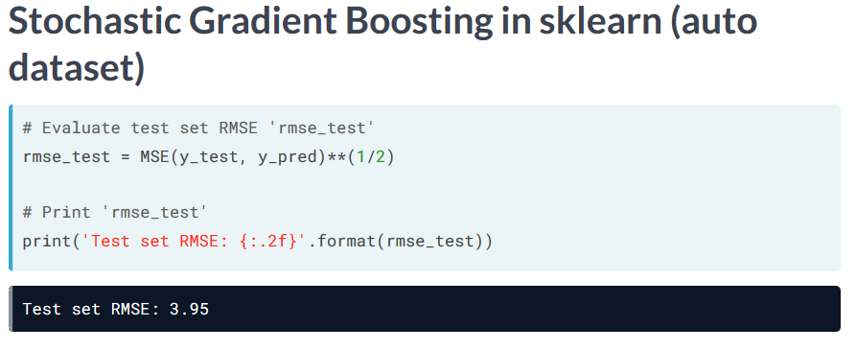

**Tuning a CART’s Hyperparameters**

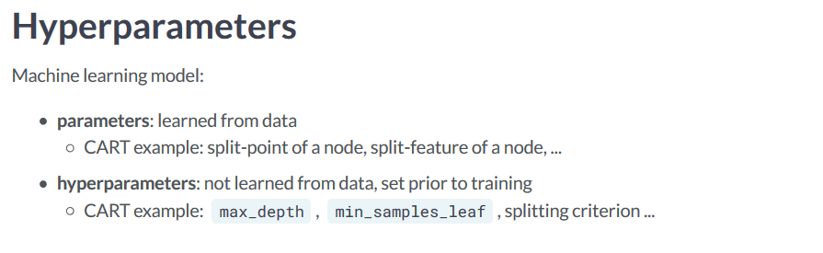

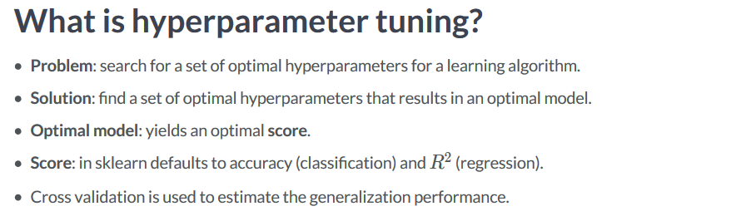

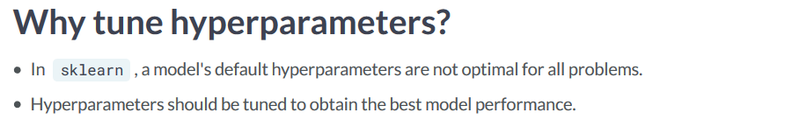

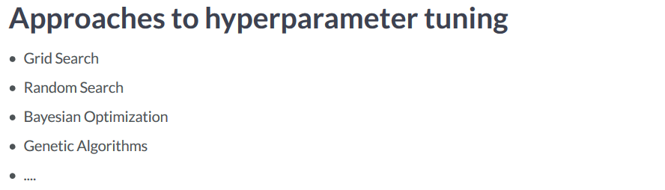

**Grid Search suffers from curse of dimensionality.**

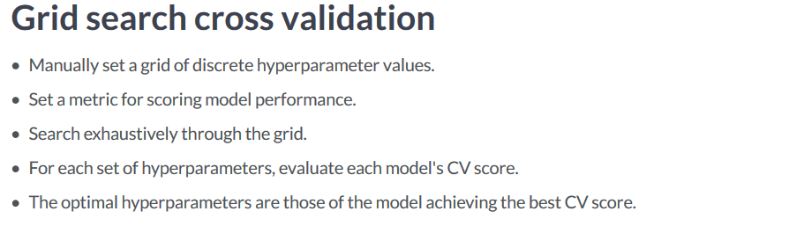

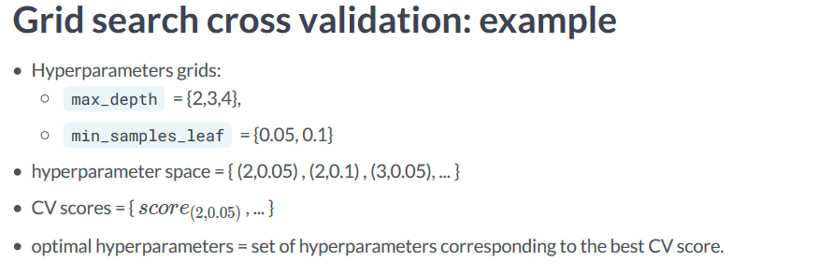

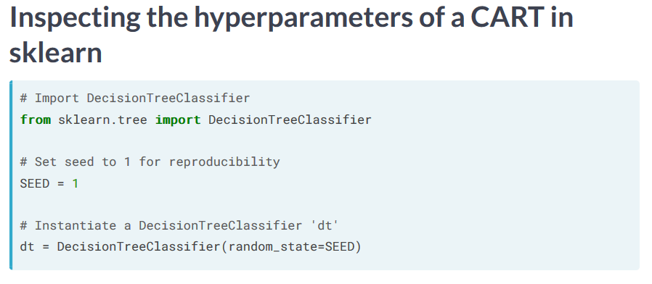

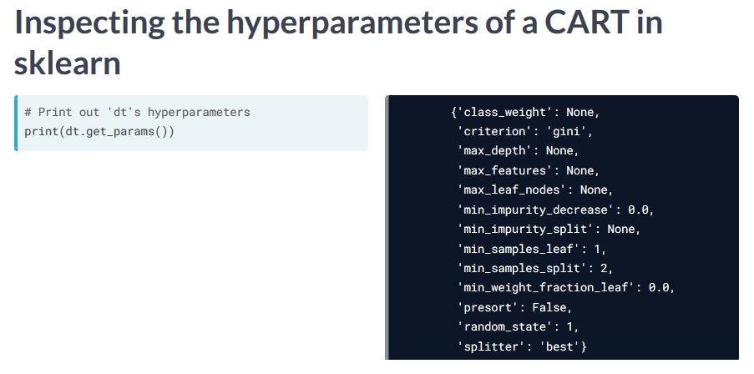

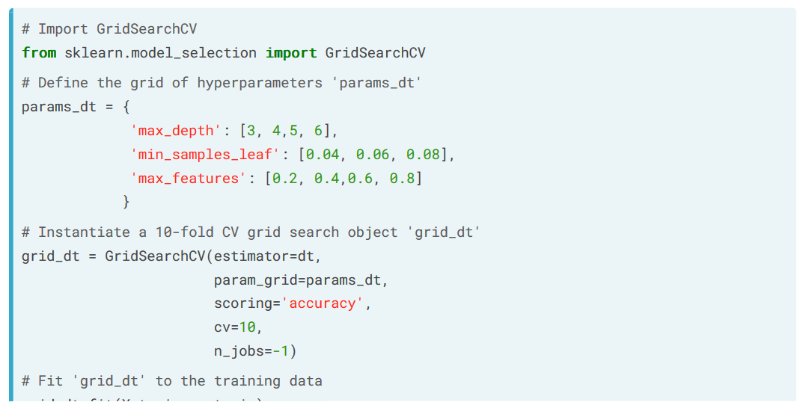

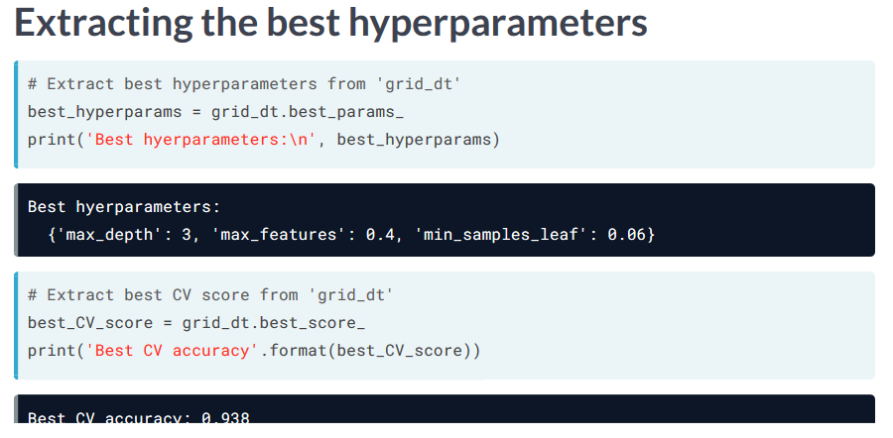

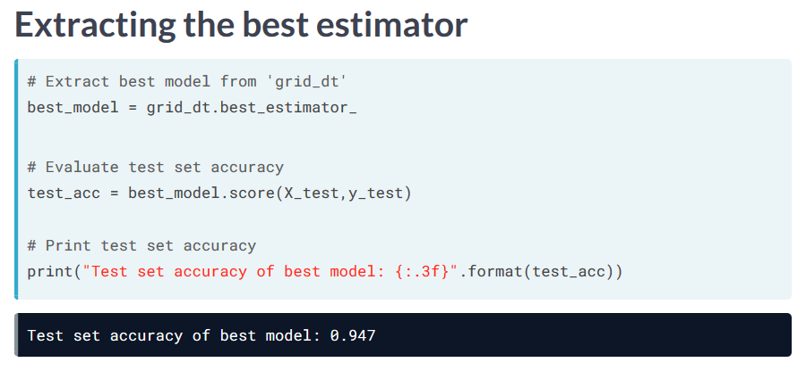

**Tuning a RF’s Hyper-parameters**

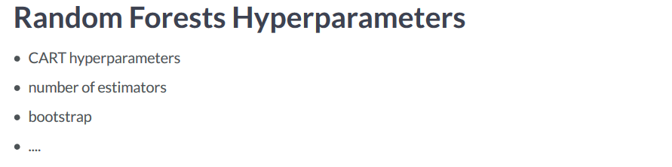

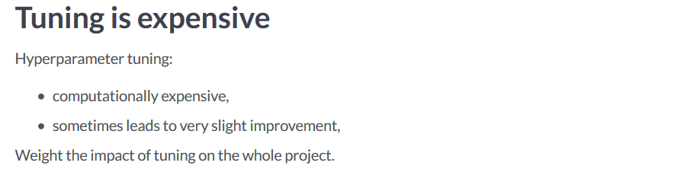

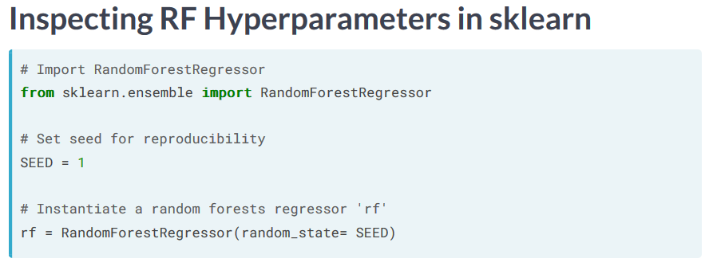

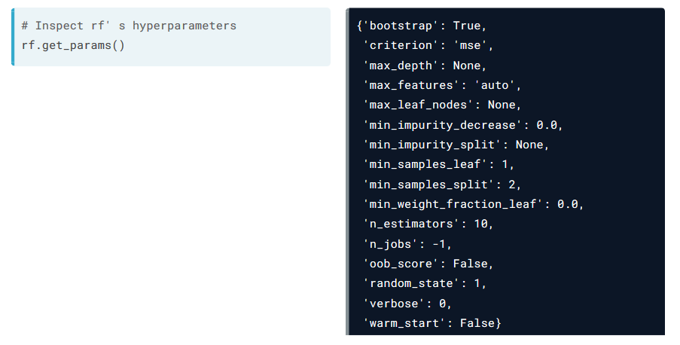

Extreme Gradient Boosting with XGBoost

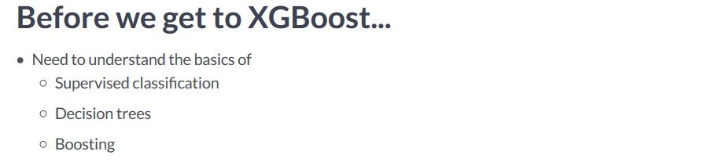

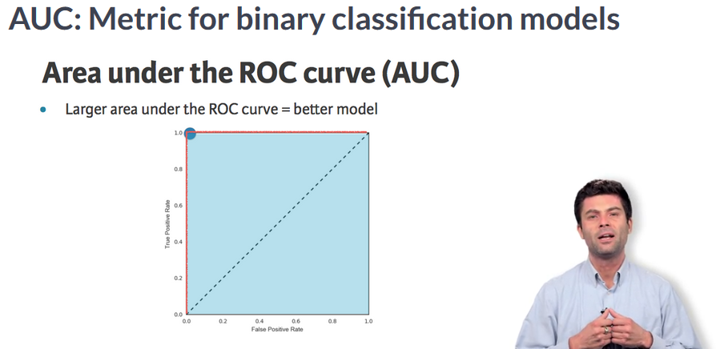

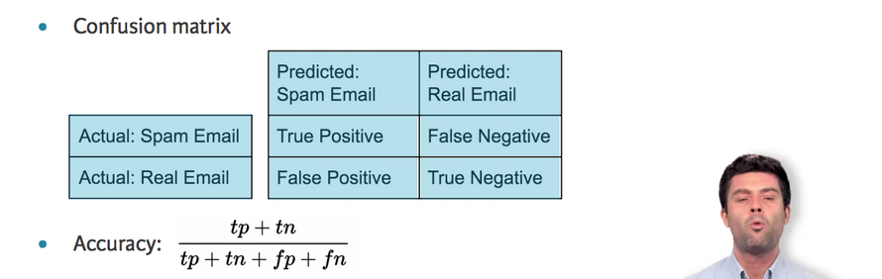

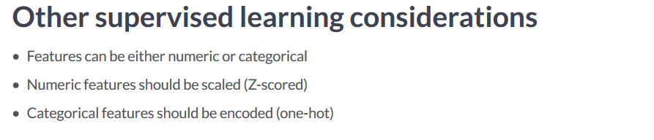

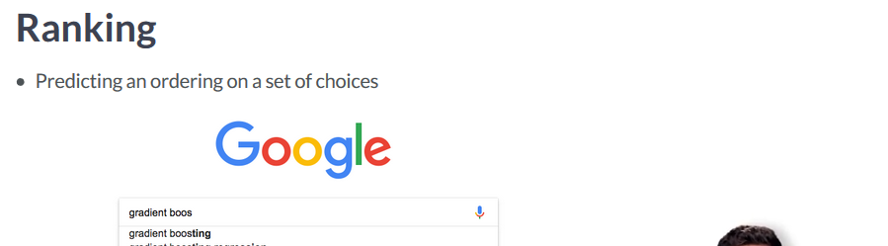

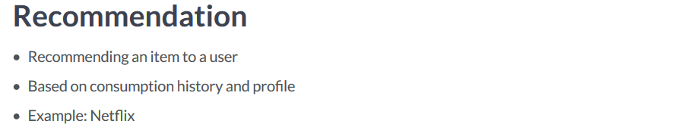

Introducing XGBoost

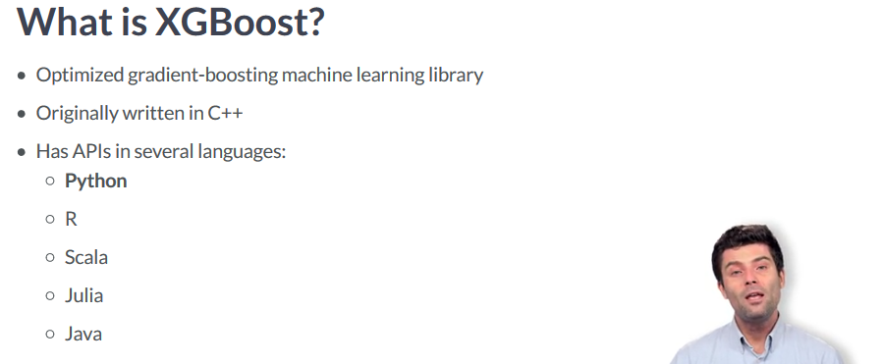

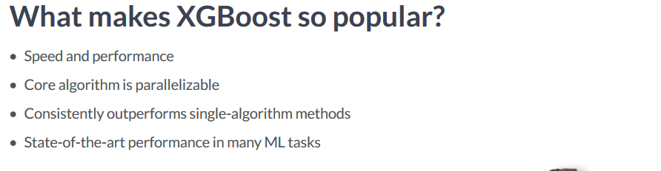

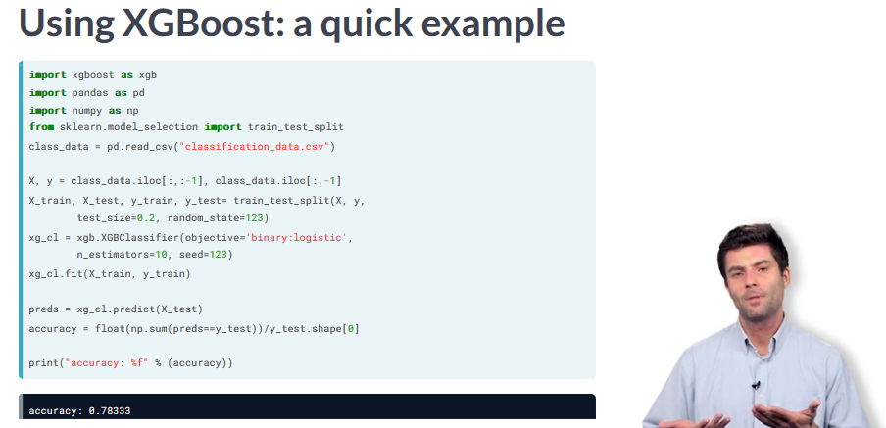

What is a Decision Tree?

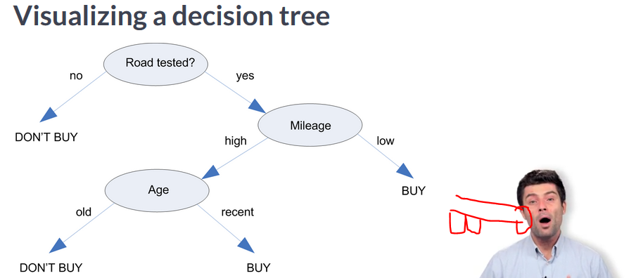

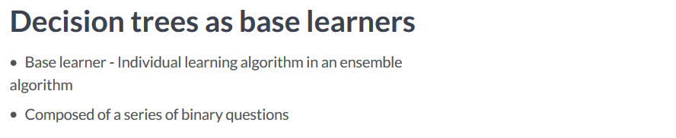

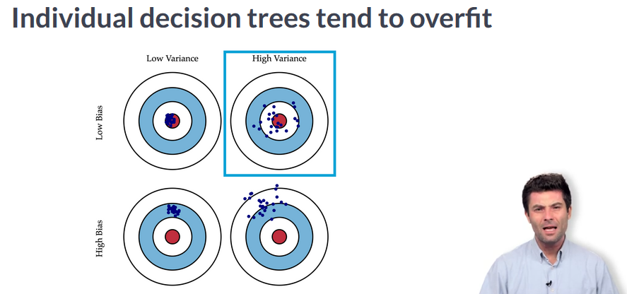

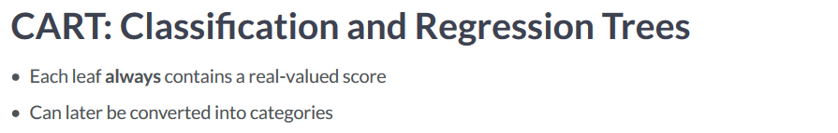

What is Boosting?

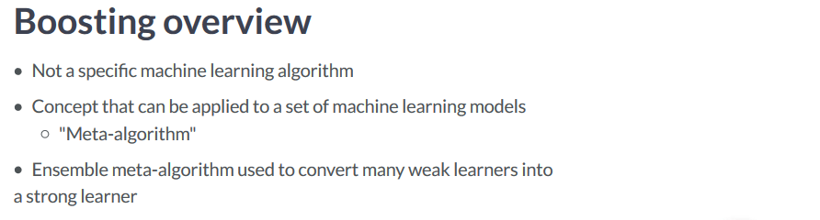

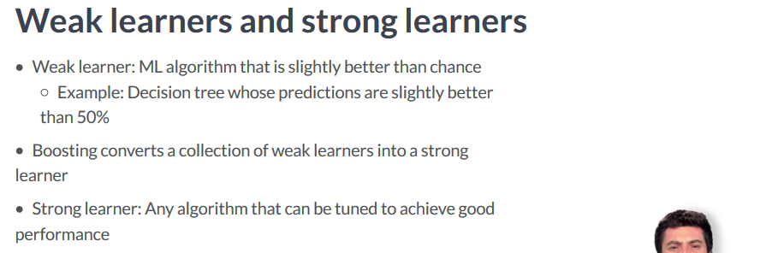

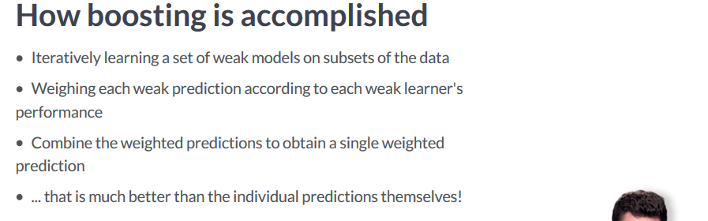

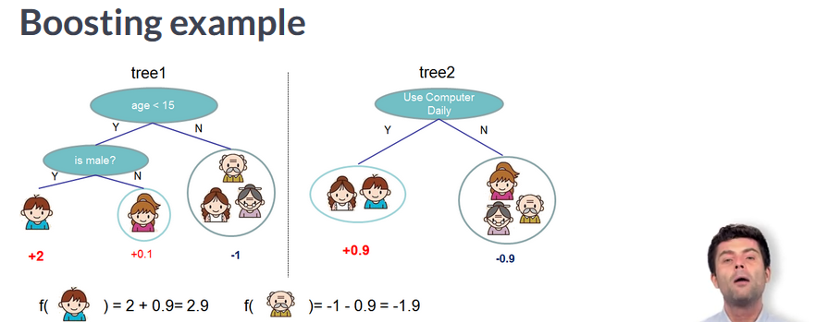

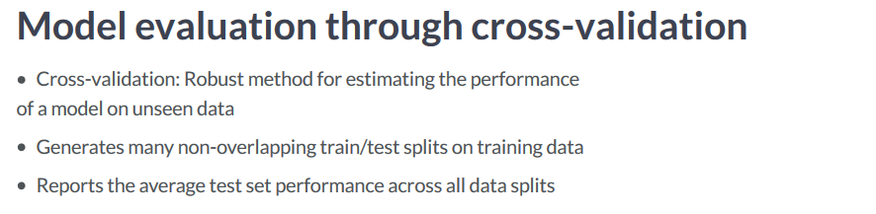

**We have to explicitly convert our data into a DMatrix before using XGBoost. This is an optimized data structure unique to XGBoost that improves the algorithm’s performance and efficiency.**

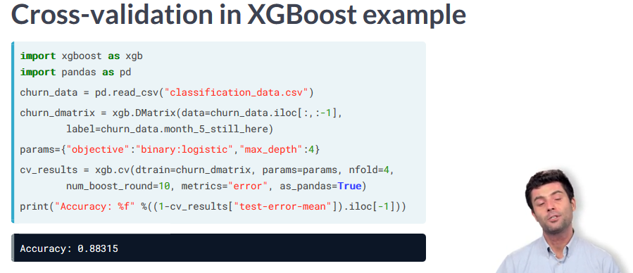

When to use XGBoost?

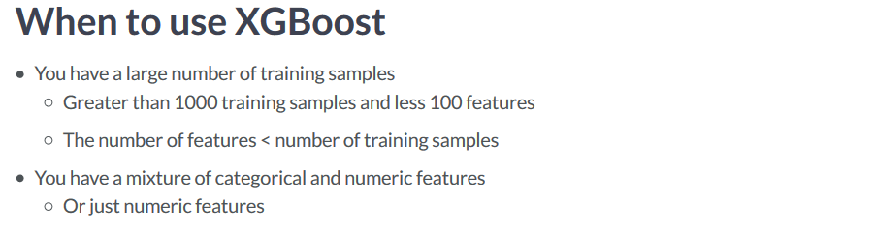

**Deep Learning** is much better suited for image recognition, computer vision, or NLP type problems

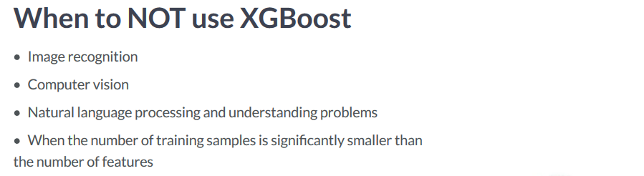

Objective (loss) functions and base learners

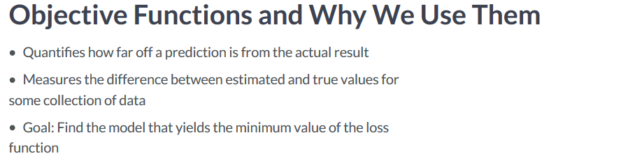

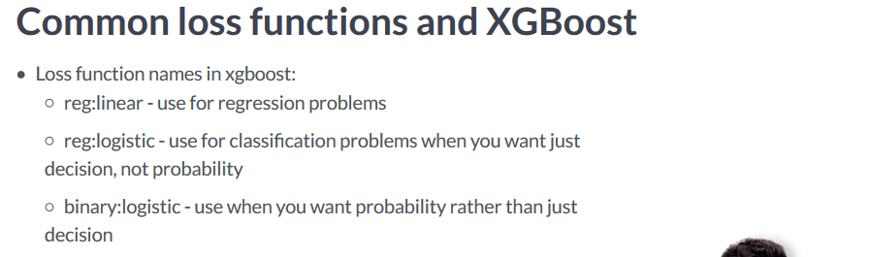

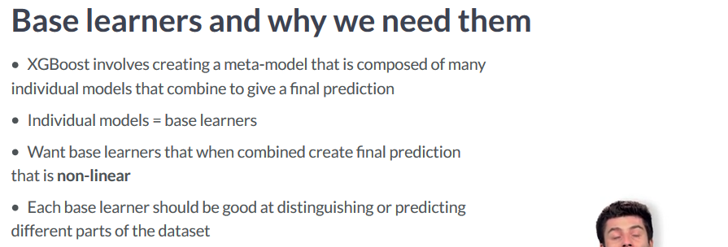

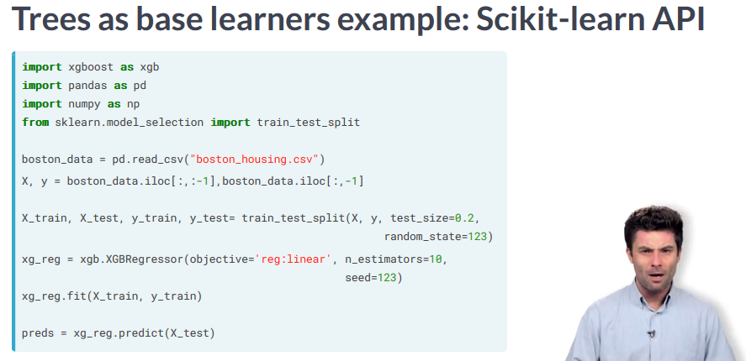

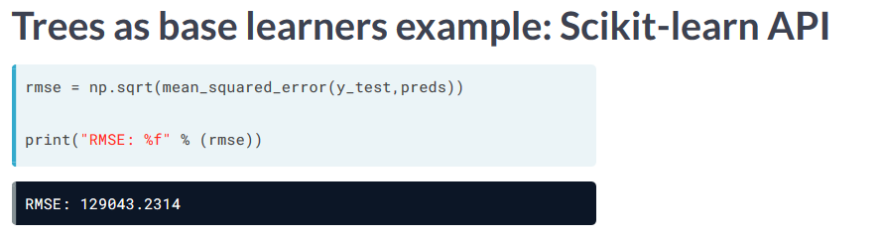

**For linear base learners in XGBoost, the data must be inputted into the DMatrix first.**

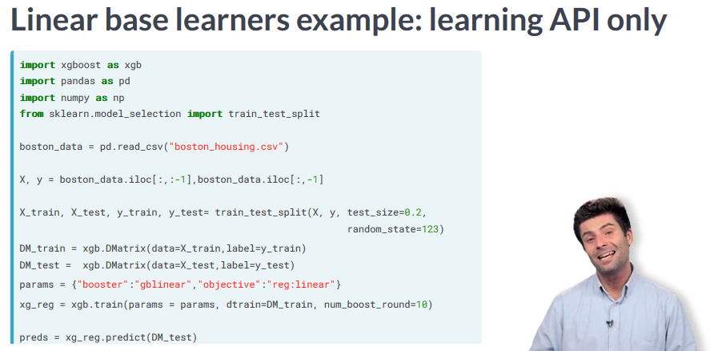

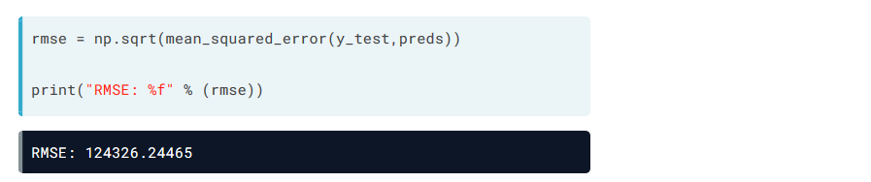

Regularization and Base Learners in XGBoost

**L2 is a much smoother regularization than L1.**

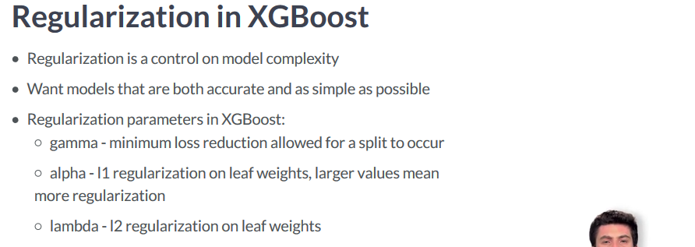

**We use a for loop to pass in different L1 parameters** 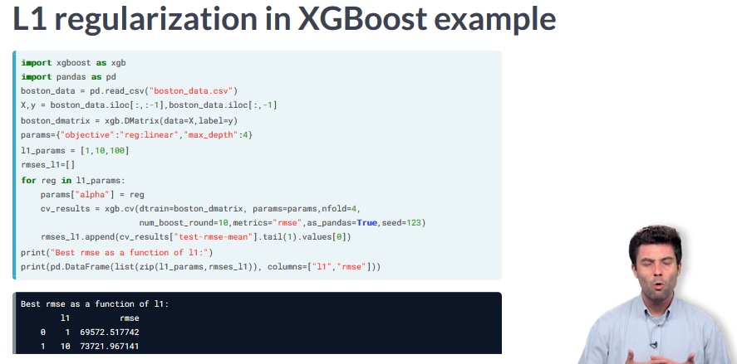

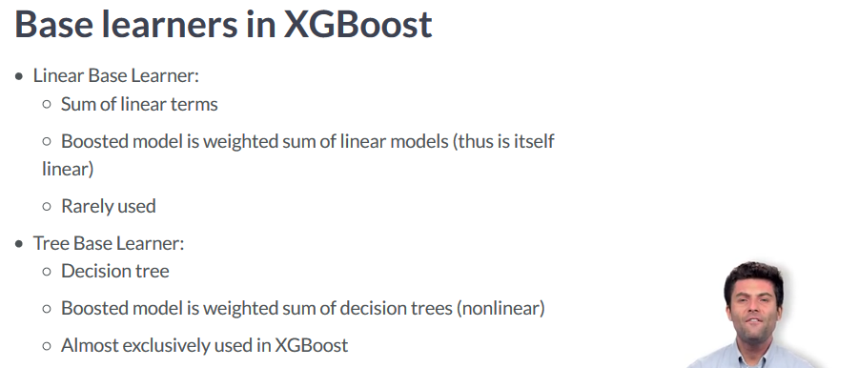

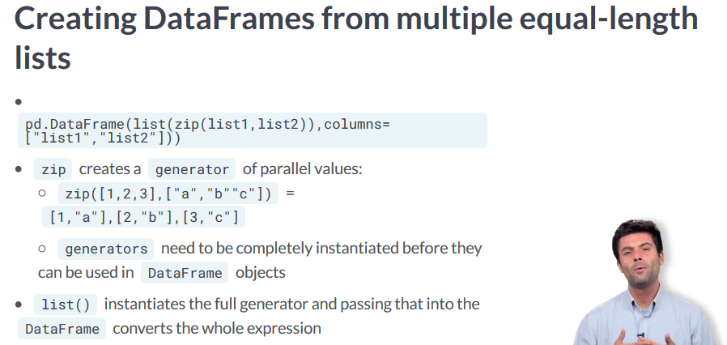

**To derive feature importance:**

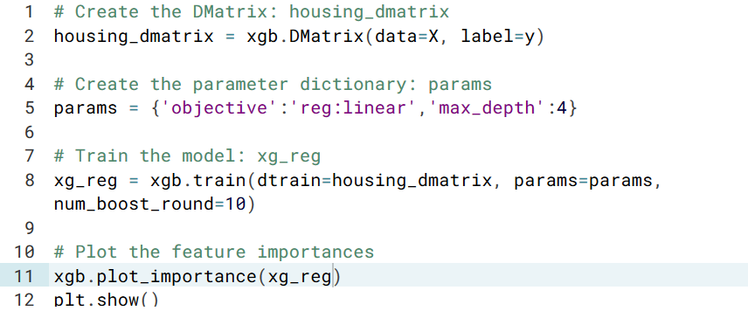

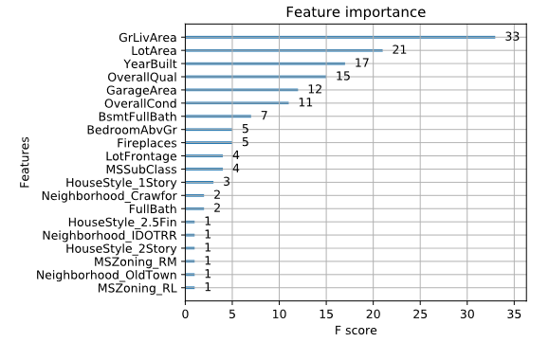

Tuning an XGBoost Model

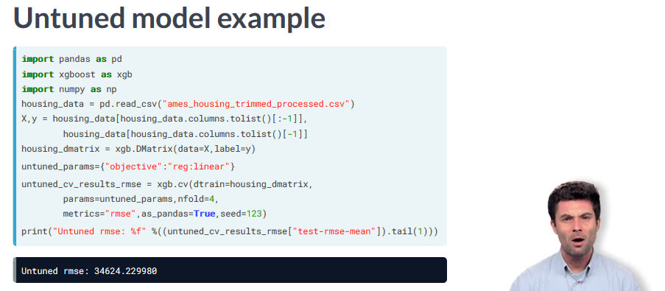

**Colsample_bytree, learning_rate, and max_depth are some of the more important XGBoost parameters that can be tuned.**

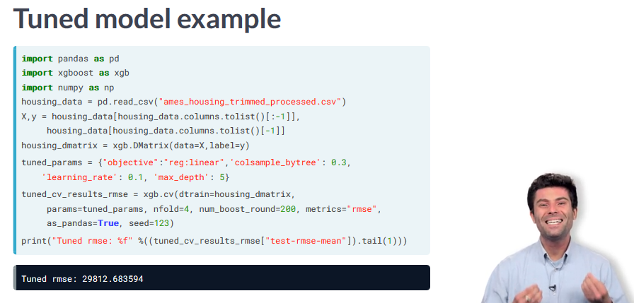

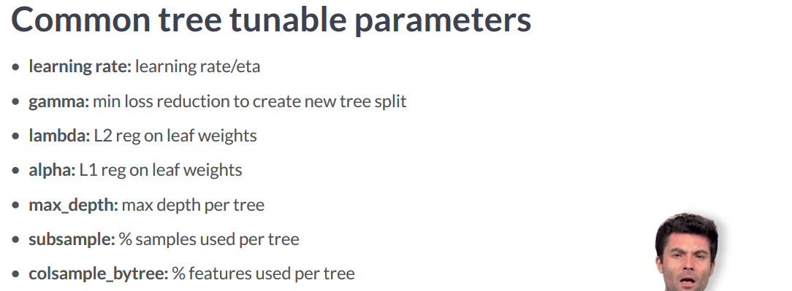

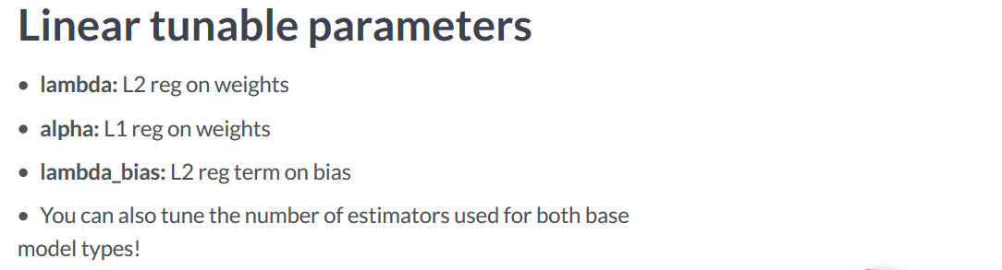

Review of grid search and random search

**How do we tune multiple hyper-parameteres at the same time:**

Grid Search: We search exhaustively through every single hyper-parameter value.

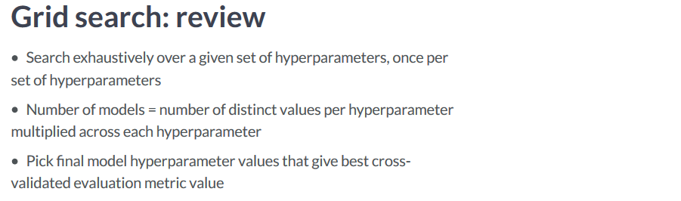

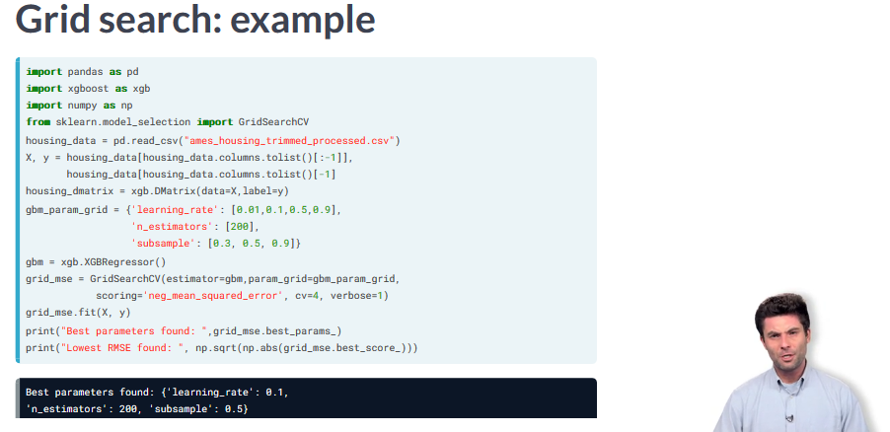

**Random Search** you decide how many models or iterations you want to try out before you stop.

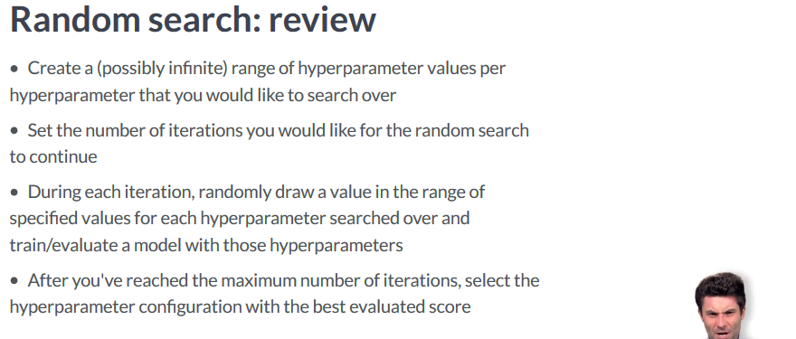

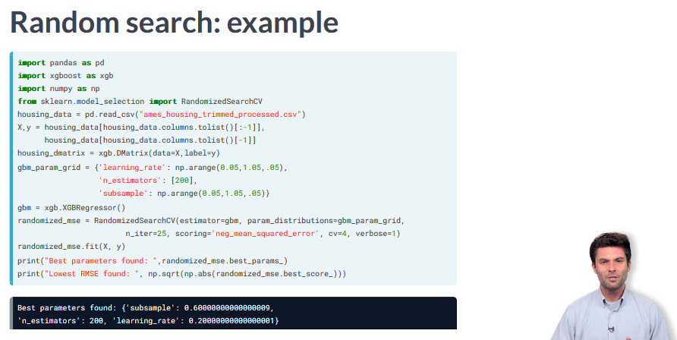

Limits of Grid Search and Random Search

**Grid Search:** Works alright with a relatively small amount of models, but adding in each new parameter causes it to grow exponentially

**Random Search:** Time to use random search doesn’t increase so much, but when you add in paramaters, jumping through the space to find the right parameters.

Hyper-Parameter Tuning: Informed Search

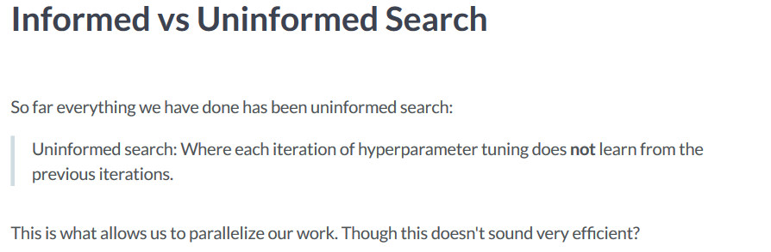

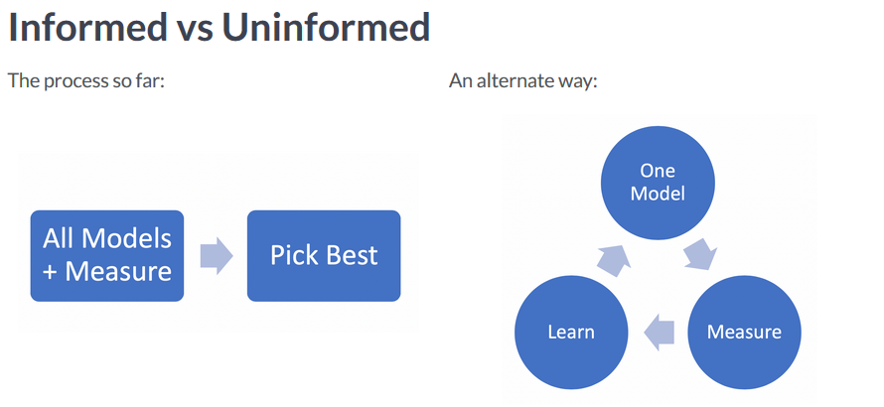

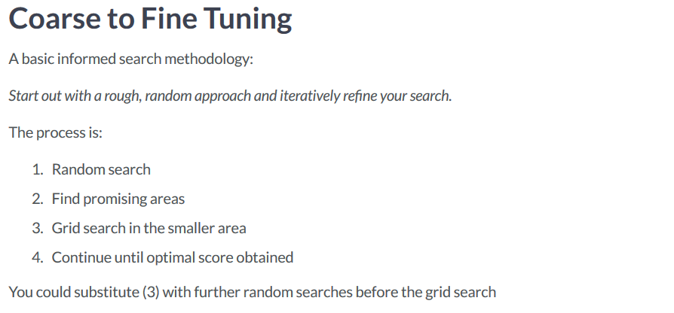

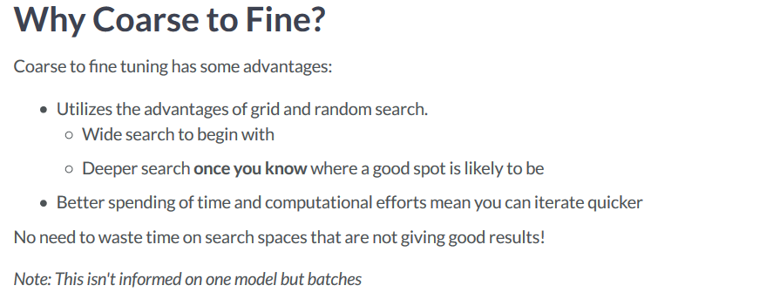

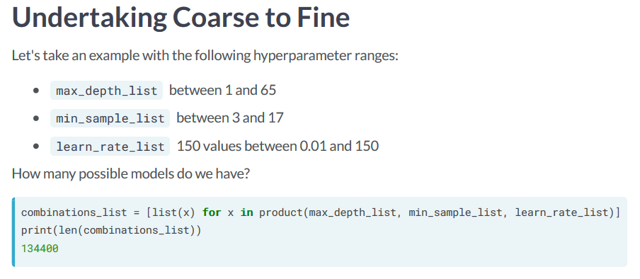

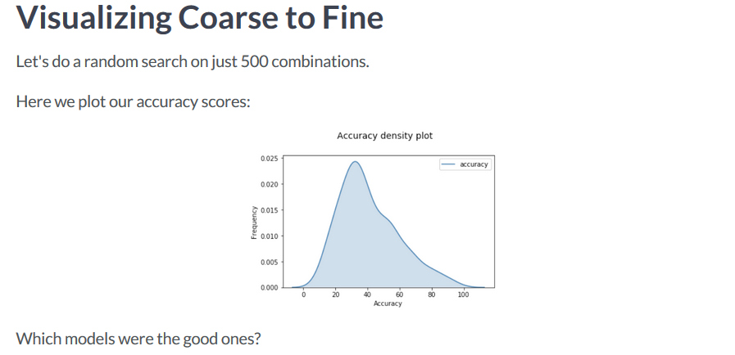

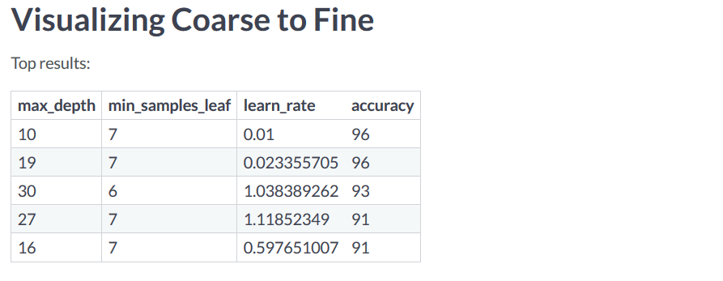

**We want to visualize each hyper-parameter to see if we can see any trends.**

**We notice that accuracy tends to be lower when outside of the 7-30 range.**

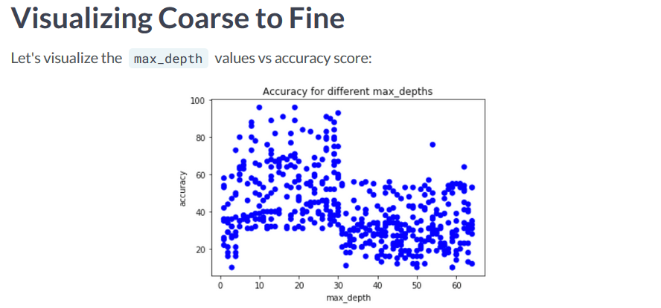

**We see some other trends as well, accuracy appears lower for min_samples_leaf when above 8, and accuracy is lower for learn rate when above 1.3**

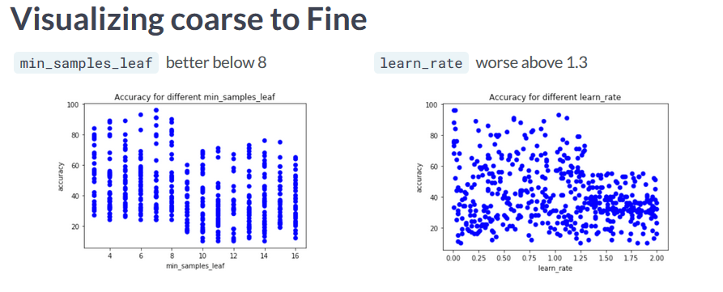

**With this information, we can perform another grid search or random search within these ranges to further improve the model.**

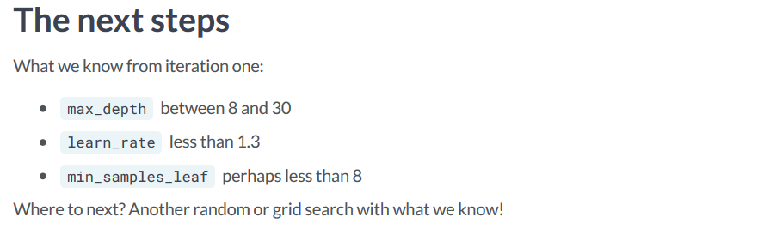

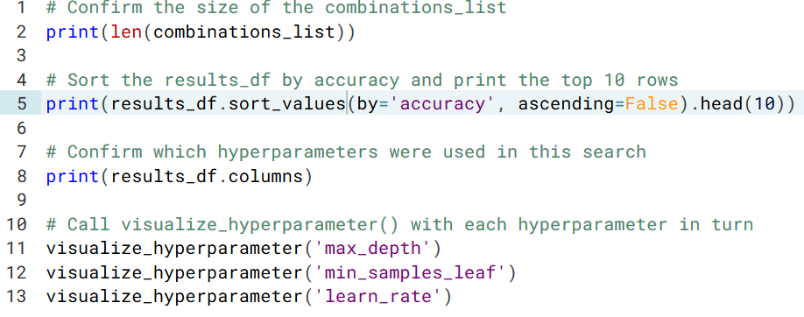

**You can use visualize_first and visualize_second to visualize the results of different hyper-parameter combinations.**

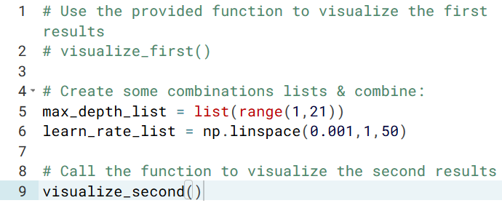

Informed Methods: Bayesian Statistics

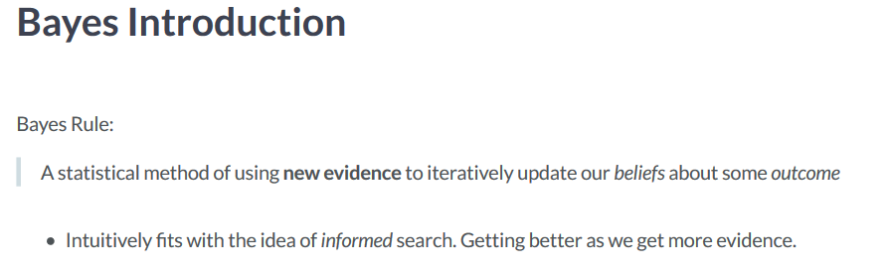

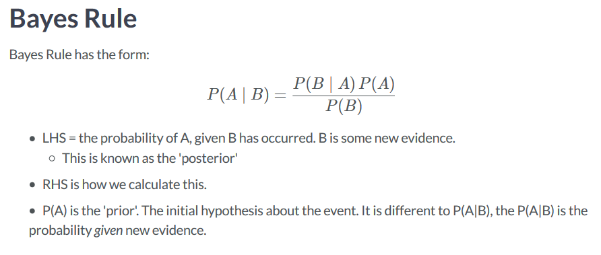

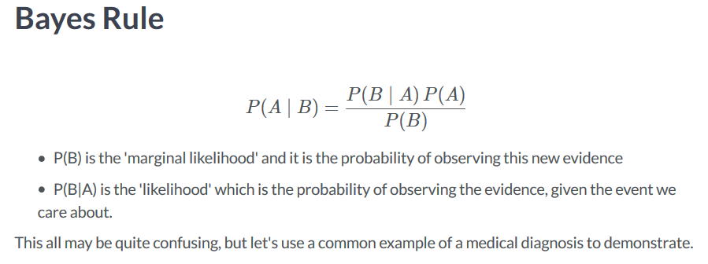

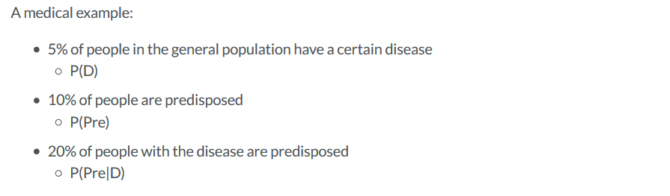

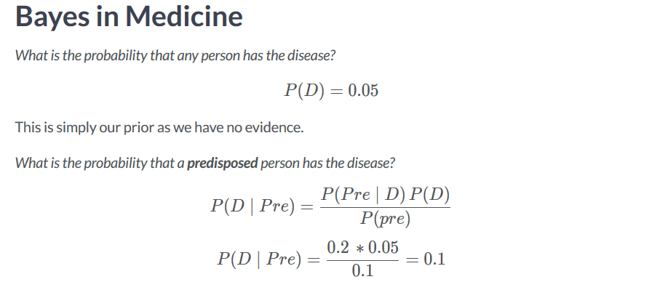

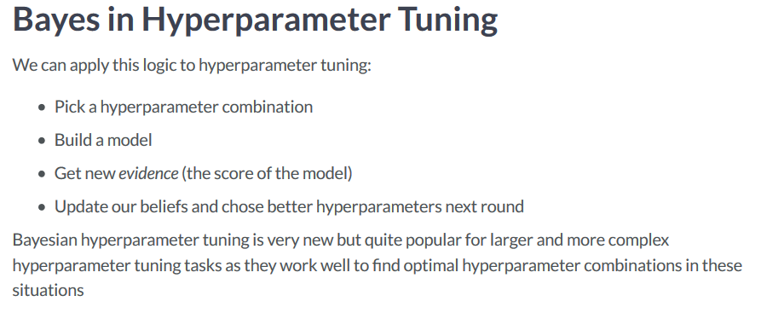

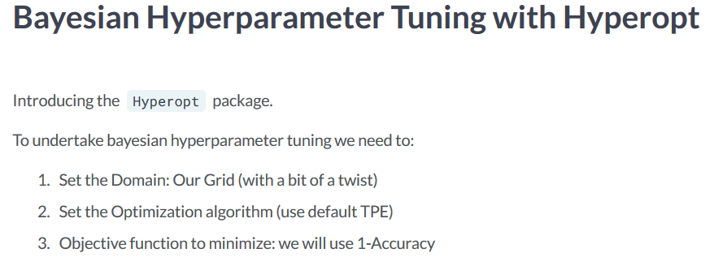

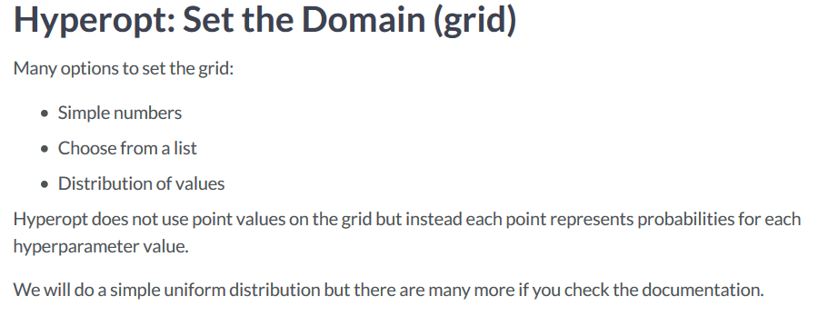

**quniform means uniform but binned by the specified 3rd number.**

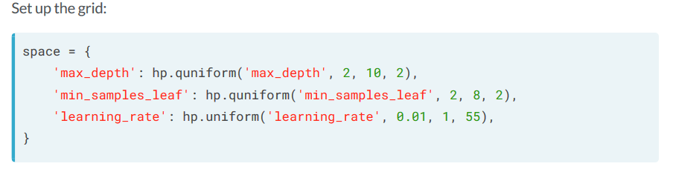

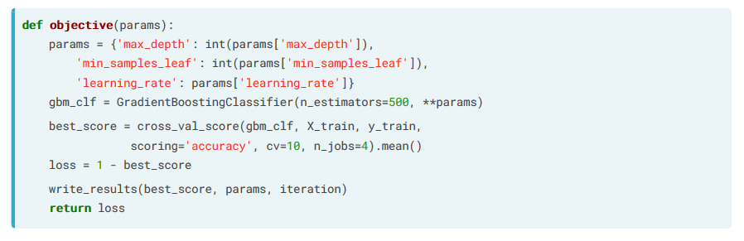

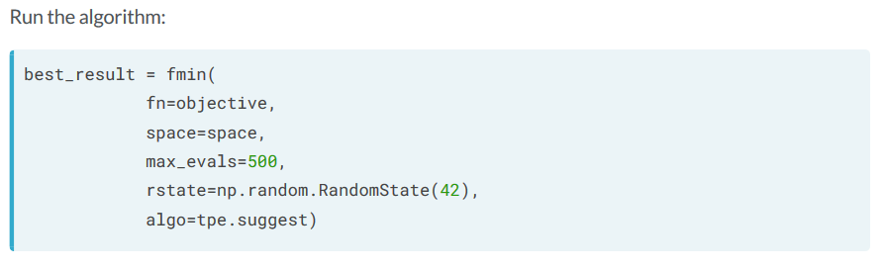

Informed Search: Genetic Hyper-Parameter Tuning

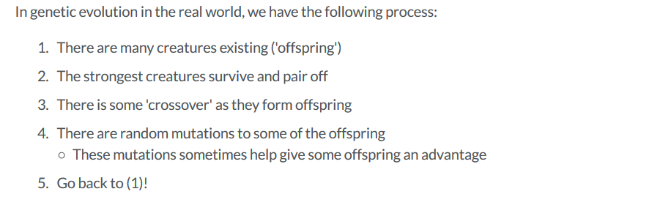

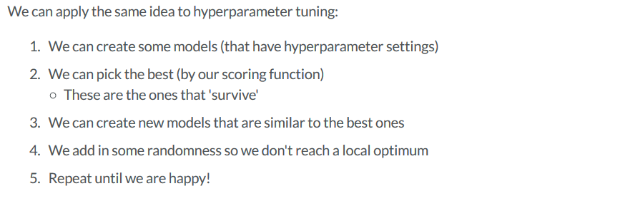

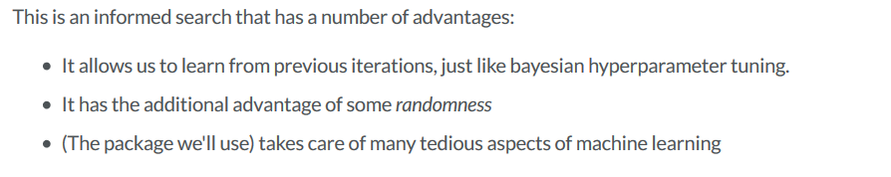

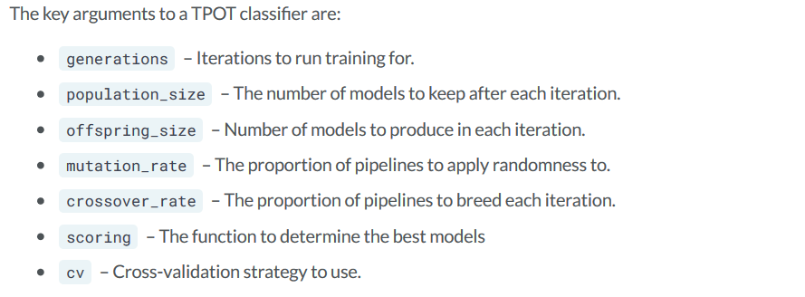

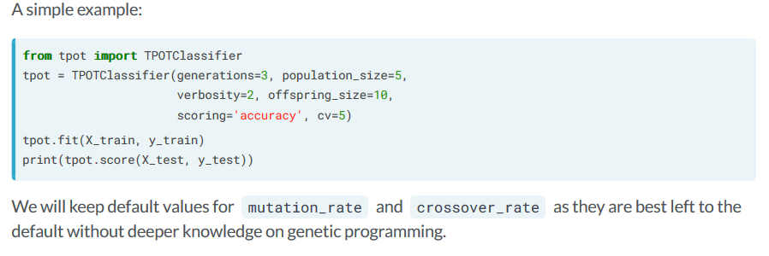

**TPOT is unstable when not run for a reasonable amount of time. You should increase the generations, population size, and offspring along with running it for a longer time to get a better result.**